Spring 2025

Friends of MD State Library

for the Blind and Print Disabled

The Friends Bulletin

LBPH’s Talented Youth Services Librarian, Lori
in Montgomery County is an example of her creativity. The event was for young budding scientists and/or all children who like making a mess. Lori read the book, and led the group as they made multi-colored Oobleck, a substance resembling play-dough. Check out the photos to see some of the beautiful creations at this event.

Spreading
A Message from Friends President Sharon Maneki

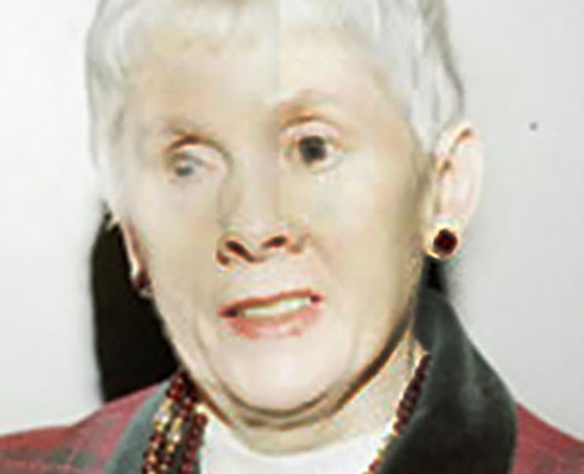
As usual, Friends plans to continue to help the library with programs, equipment, subscriptions to Bookshare etc. This year we are concentrating on spreading the joy of reading to the many seniors, working-aged people and children who have not yet heard of LBPD. We are doing this by working with the Baltimore Banner, which is an up-and-coming newspaper that covers Baltimore, Baltimore County and Howard County. We are also advertising books for children about Chesapeake Bay throughout the Maryland school systems and providing a prize to those who sign up with the library. We hope that these efforts will lead to more people using LBPD services.
The National Federation of the Blind estimates that, in 2016 (the latest date of available statistics), there were 116,500 blind people in Maryland. In 2024 the library served 5,306 patrons. As you can see, we have a long way to go, but we are up to the challenge! We hope you will help us by making a financial contribution.
You are an integral part of Friends. We need your ideas for new programs, technology and equipment that Friends can sponsor. We are looking for your suggestions for innovative projects that Friends can take on. Look in future newsletters for reports on the success of this marketing campaign.
We thank you and know that together we will continue to spread the joy of reading to the blind and print disabled citizens of Maryland.

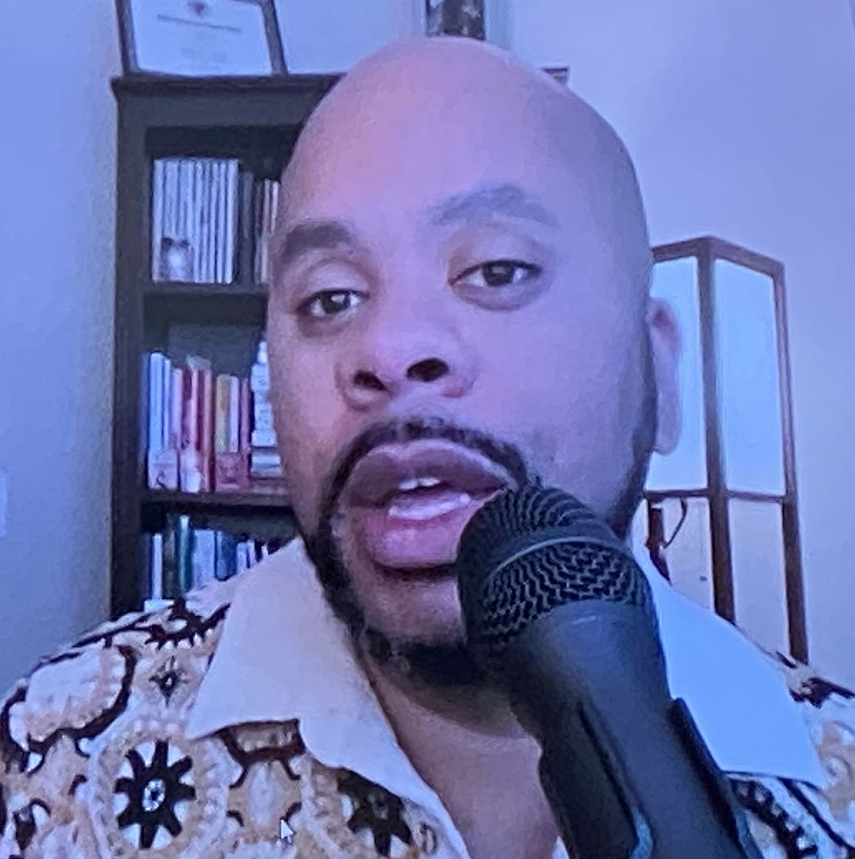The Friends and Patrons of the Maryland Library for the Blind and Print Disabled (LBPD) know that our library is great because of the staff and the opportunities that they create. Now, everybody else in the library community knows it too.
LBPD was recognized on July 18th as the Regional Library of the Year by the National Library Service for the Blind and Print Disabled, Library of Congress. This is a coveted award that libraries compete for throughout the country.
The ceremony took place at the Library of Congress in Washington, DC on July 18, 2024. Each nominee was rated on the following categories: mission support; creativity and innovation; patron satisfaction with the services, as well as a profile of the library.
Highlights of LBPD include providing 680,000 materials to the over 7,000 people served by the library. Additionally, 141 patrons were provided with Bookshare accounts, which amounted to 3,349 items being downloaded from Bookshare. Finally, the library recorded 300 locally produced books about Maryland and by Maryland authors and made them available on the Braille and Audio Reading Download (BARD) service, making them available to the rest of the country. The Friends are proud to highlight the incredible library staff on pages 4-6.

Spreading
the
Joy
of
Reading

Contact Us:

Friends of MDLBPD
672 Old Mill Road, #128
Millersville, MD 21108

friends@friendsmdlbpd.org

Friend us at:

www.facebook.com/lbph
friends

We’re on the Web!

http://friendsmdlbpd.org

Special Recognition for Two LBPD Staff Members

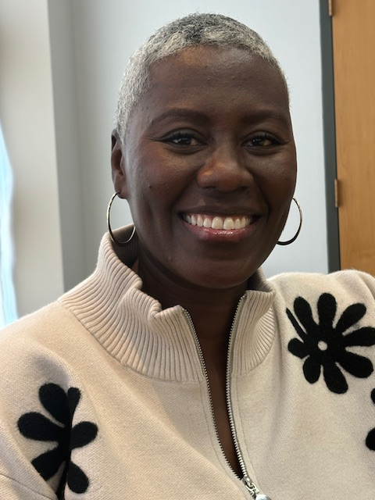
LaShawn Myles received the 2024 Mover and Shaker award from the library journal. She established the Maryland Inclusion and Accessibility of Practice of Public and School Library Staff. The purpose of this group is to increase inclusiveness and accessibility to their services. During her tenure on this committee, LaShawn helped Maryland Libraries bring two national programs to the state. Project Ready focuses on improving library programs and services for African American, Indigenous, Latino, and Asian children and teens in the US. The second national program was Project Enable, improving services for people with disabilities.
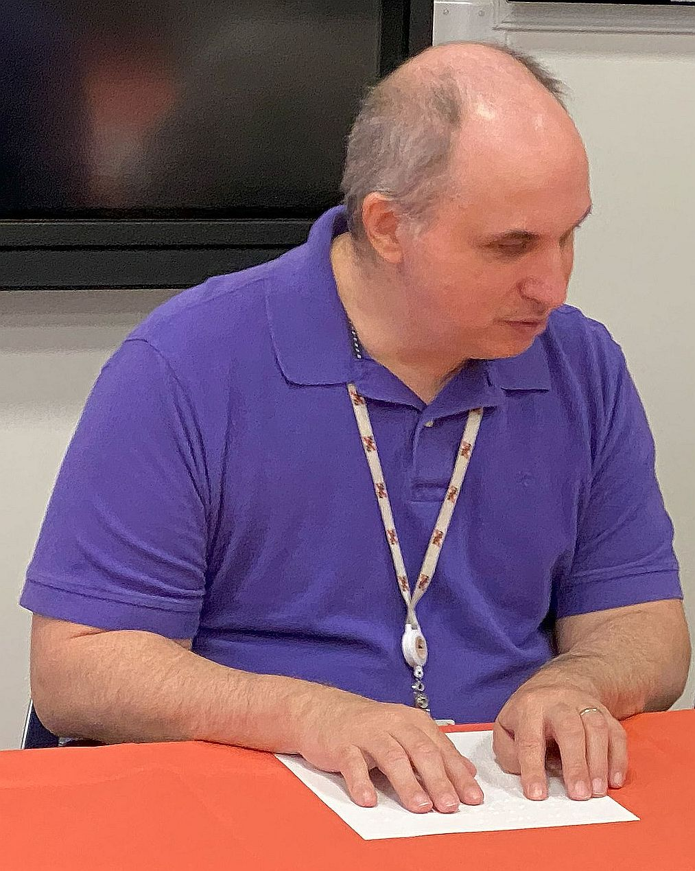
Jerry Price received an honorable mention as a Digital Equity Champion. He received the award on October 15th, 2024, at the technology summit. This award was presented from the Marylanders Online Program of the University of Maryland Extension. Marylanders Online is a free, statewide program of the University of Maryland Extension in partnership with the College of Information working to promote digital literacy, equity, and inclusion throughout the state of Maryland. Jerry was recognized for his leadership of the technology users group, sponsored by the Maryland Library for the Blind and Print Disabled. This is a monthly program that discusses new technologies and issues related to technology for the blind. He also was recognized as an outstanding teacher of technology to many library patrons.
Congratulations to both LaShawn and Jerry for their outstanding work!

Friends Annual Meeting
October 26, 2024

The Annual Meeting with New State Librarian and Two Authors on Sunday, October 27th went off in fine style! President of Friends Sharon Maneki opened the morning by greeting all staff, patrons, and Friends and handing out some Amazon gift cards as fun door prizes. Thanks to Friends Executive Secretary Cynthia York, all the tables in the meeting room were festooned with tablecloths in fall colors and there were treats on the tables for snacking.

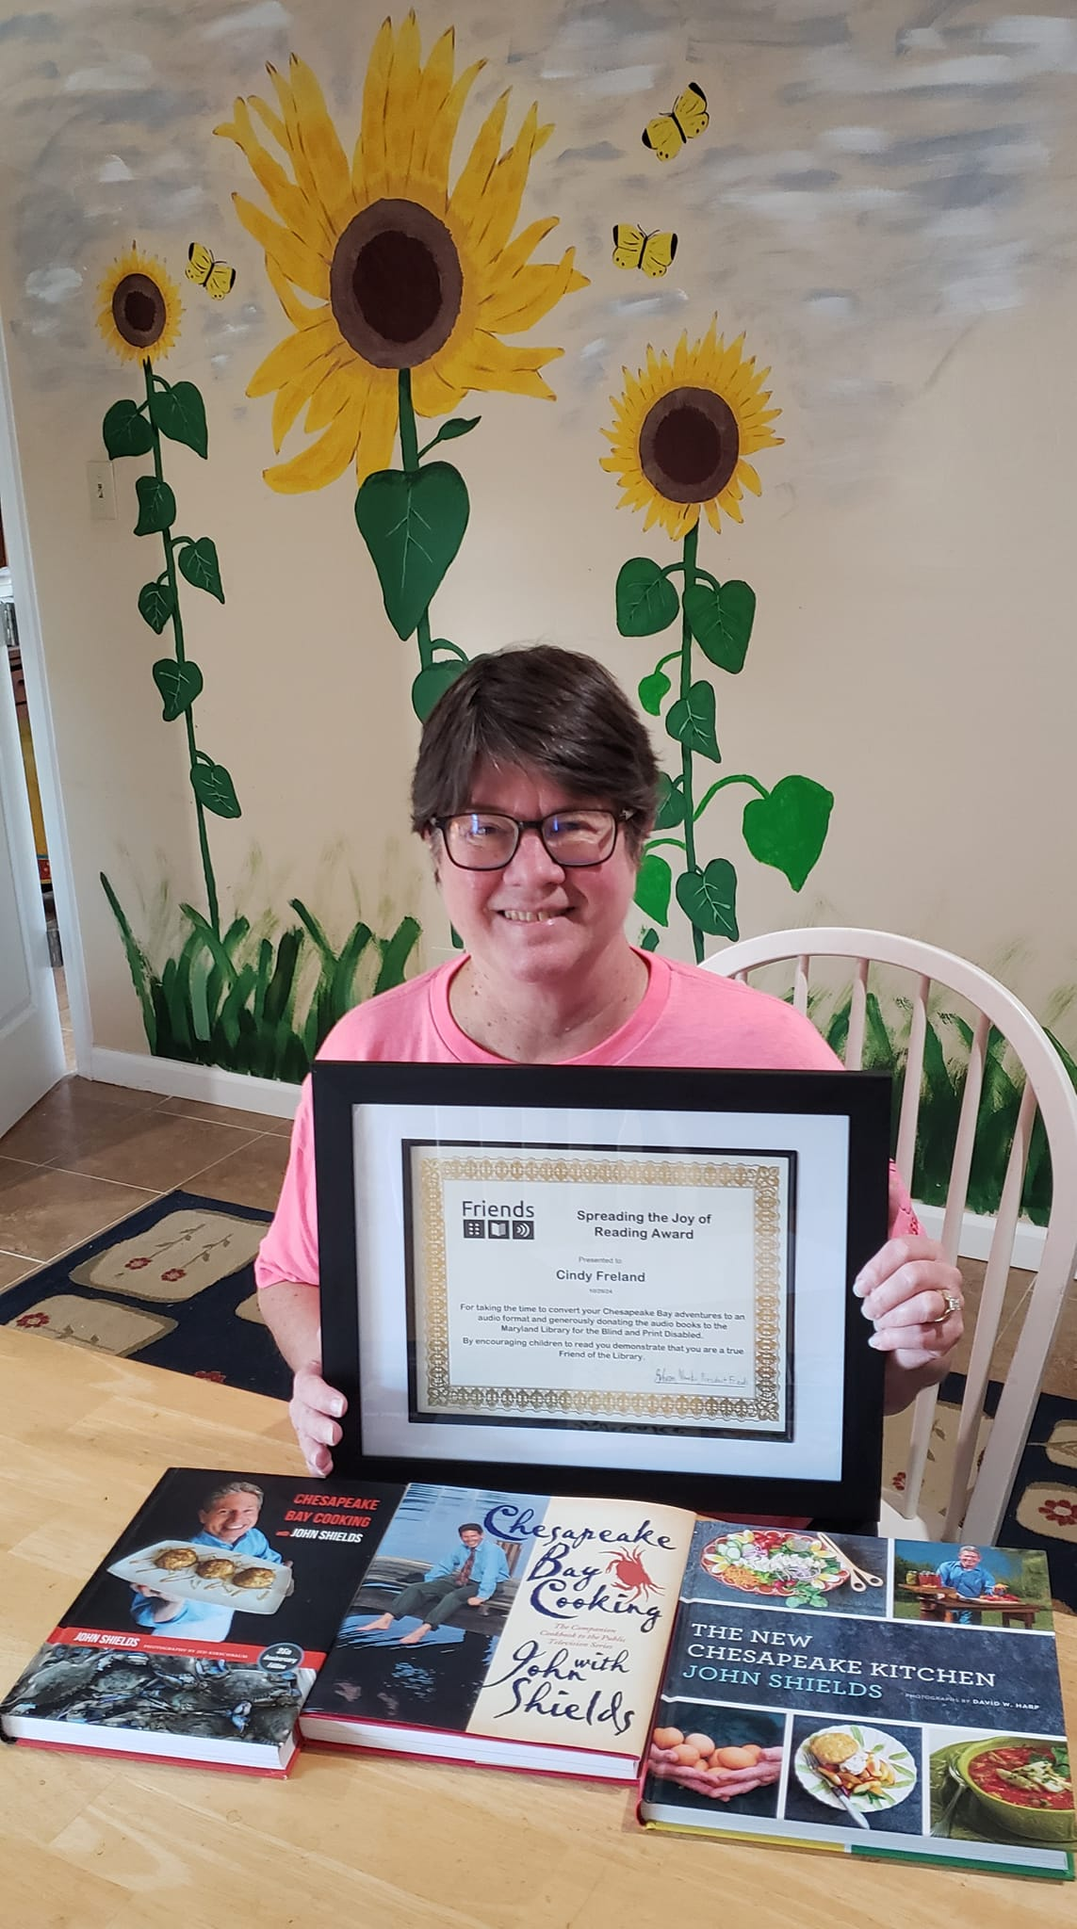
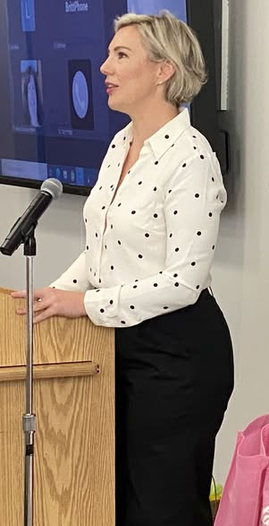
Sharon introduced the guests and speakers, including our new State Librarian Morgan Miller, who told us what’s happening in the State Library Agency, the Deaf Culture Digital Library and the Dolly Parton’s Imagination Library, an initiative that sends free books to children from birth to age five, in five countries. She spoke about the importance of accessibility to materials, and praised LBPD for providing excellent service to the community it serves. Maryland is the only state that has a MAT (Maryland Accessible Textbook) program, run by Joe Beckett. All Black-Eyed Susan titles for this year have been selected and recorded by staff and are now up on BARD in an accessible format. Jerry Price, facilitator of TUG, the Technology User’s Group has been named Maryland’s Digital Equity Champion for his work. Morgan also mentioned Book Share and how vital this is for users.

Our first keynote speaker, Cindy Freeland calling in on Zoom She is the author of ten children’s books about one of Maryland’s great treasures, the Chesapeake Bay. She uses animals that inhabit the bay to tell the Bay’s stories. Her books are self-published and available on BARD. Sharon thanked her for donating them to LBPD and presented her with three Chesapeake Bay cookbooks by John Shields.

Dr. Cheryl Fogle-Hatch, a Baltimore-based archaeologist and accessibility consultant was up next, speaking about a tactile art exhibit entitled “Founding Fossils” on display at the Peale Museum until December 22. Founding Fossils is a multi-sensory exhibition that includes 3D-printed versions of fossils originally collected by the Peale family and early American leaders. The exhibition will interweave replicas of the mastodon fossils with tactile versions of a graphic novel series created by Dr. Bernard Means and students from Virginia Commonwealth University. Visitors can read the Braille labels and touch the exhibits.

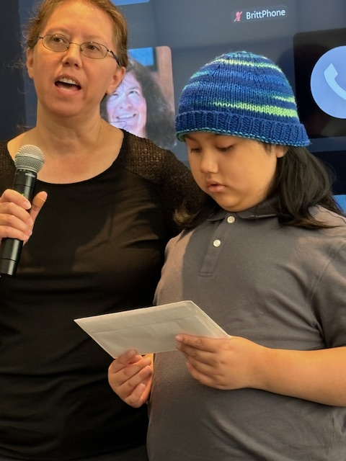
The Estelle B. Williamson Award was presented next. This important committee which promotes Braille literacy was chaired by Friends Vice President Barbara Cheadle with help from Friends Dezman Jackson, Gary Hawbaker, and Ellen Ringlein. and promotes Braille literacy. This year’s winning applicant was Talex Sacbibit. He and his mother accepted the monetary donation and will use the money for mobility training and navigation.

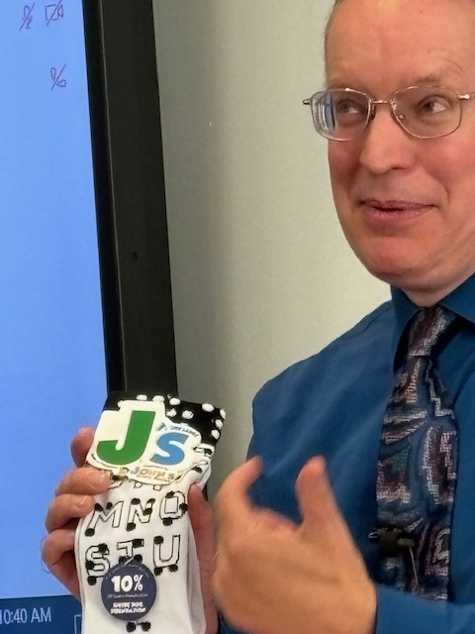
Sharon then recognized LBPD’s many volunteers who give their time in the Recording Studio and Tech Services. They were given a Dunkin Donuts gift card and clever Braille socks. John Owen, Director of LBPD also received a pair of these socks.

The second keynote speaker was Eric Thomas calling in on Zoom, a syndicated advice columnist for the Washington Post and the Baltimore Sun and the author of several books, many of which are on BARD.
Here for It: Or, How to Save Your Soul in America, is a series of essays about his life experiences as a black gay Christian man. Kings of B’More is a novel about two friends who embark on an adventure in Baltimore.
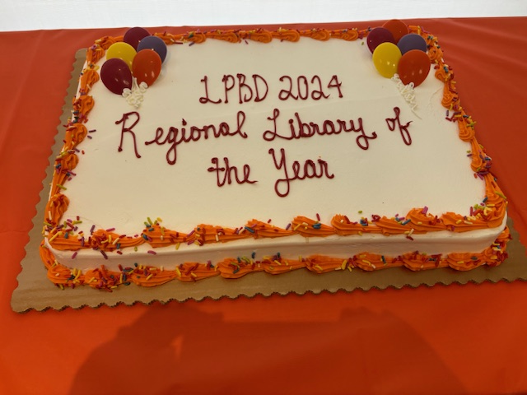
A lifelong lover of libraries, his takeaway quote was: “A library is an open window in a world full of closed doors.”
A delicious lunch of sandwich pinwheels, chicken nuggets, veggies, and fruit and chips was available to all in the hall with a sheet cake commemorating LBPD’s Regional Number One status in the meeting room. A huge thank you to Cynthia York for planning and setting up, and serving all these treats!
A very fulfilling morning was enjoyed by all. Thank you to John and staff for setting up the meeting room and clearing away all the trash, to Outreach Librarian Ashley Biggs for snapping photos, to Cynthia for providing all the food, to Sharon Maneki for handling the podium and conducting business, to Friends Treasurer Mike Davis for helping Sharon give out awards, and to Friends Gary Hawbaker and Liz Cooper for driving several hours from Western and Southern Maryland to share the morning with us!

My Tech News is a “Must Read!”
My Tech News is an incredible resource bulletin for those interested in the latest technology at the Library. The Friends highly recommend that you check out the 2025 Winter Edition. https://bit.ly/MTN12025

Take a Hike!
The 2025 Virtual Hike offers a month-long, accessible exploration of the Hundred Acre Wood, allowing participants to enter the whimsical world of A.A. Milne’s classic stories. Running from April 1 to April 30, this virtual experience will enable participants to engage in a reading (and hiking) challenge like no other.
https://msla.maryland.gov/Pages/2025VirtualHike.aspx

Please check our Website and Facebook page for additional news, updates, and activities.
Surprising, Interesting, and Cool Facts About the Library
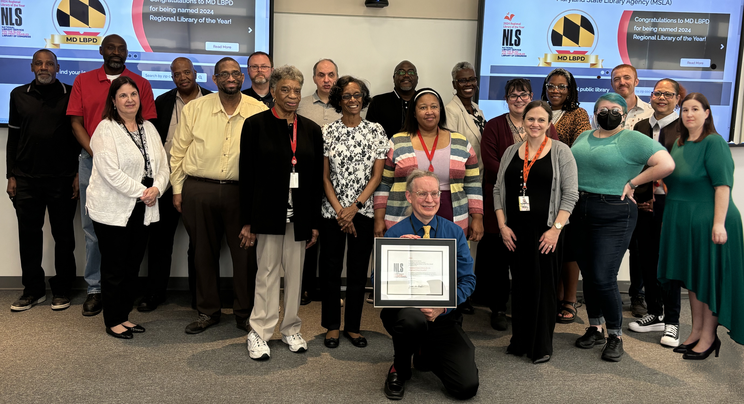

When asked to share something about the library that many people would find surprising, interesting, or “cool, ”this is what some of the LBPD staff members said:

Our patrons are from all over the state. LBPD is currently the only state library that has a program dedicated to providing formatted/ accessible textbooks to print-disabled students. (Fun fact) It is believed that the Library for the Blind and Print Disabled was built on a burial ground. Joseph Beckett- Education Coordinator

When I tell someone that I work for the Library for the Blind and Print Disabled, they say, “Wow, Do you teach them Braille? Can you read Braille?”
Patricia Bennett- Office Assistant

We’re more than books. We offer programming, events, textbooks and assistive technology training. Ashley Biggs- Marketing &Outreach Librarian

I still find (and rescue) 90’s technological artifacts when exploring the basement levels. Chris Carter- Computer Network Specialist

I really like all of the programs that we have to offer. From Tactile Art Club to the Technology User Group, there is literally something for everyone.
Brittany Grasser- Management Associate for the MAT Team

We are a great team of individuals with many different talents who enjoy working together. Se’an Herbert- Procurement Officer

The national Library Service for the Blind and Print Disabled (NLS)Library of Congress was established by an Act of Congress in 1931 to serve blind adults, but was later expanded to include children in 1952. Not matter you age, once a patron, always a patron. Your eligibility never expires. LaShawn Myles- Youth Services Librarian

Books on Demand cartridges can fit up to thirty books! John Owen- Director

We have 3 basement levels underground, so our basements are deeper underground than you can see looking at the exterior of the building. Secondly, the Enoch Pratt Free Library is a canopy over the roof of tour building so our building looks bigger than it really is. Donald Adrian Palmer- Maintenance Chief

When people think of LBPD, they often only think of our services to the blind and forget that we also serve individuals who are print disable. Actually, only 40%of our patron base are blind. That means that 60% are print disabled. People with visual impairments make up the majority of that 60%, but we also serve print disabled individuals who have physical limitations of perceptual disabilities. It is also interesting to note that over half of all our patrons are seventy years of age or older.
Mary Ramos-Assistant Director

Over the past six-plus years, the Maryland LBPD has added 327 digital talking books to BARD! Andrew Russell- Recording Studio Manager

There’s a rumor of a library ghost. It is said that he haunts the stacks on B3.
Denise Sellers- Office Secretary

People are surprised that books, whether reality or drama, can come to life for them.
Larry Smith- Technical Services Equipment Manager

The Joye of Cooking is about 1200 pages long in standard print. We have the whole of it in Braille. In Braille, it is 30 volumes!
Taryn Tranby-Admin.Officer- Patron Services/Readers Advisory

We serve the whole state of Maryland and we were recently named Maryland Library of the Year.
Mozetta Trueheart- Administrative Specialist II (Patron Services)

Since the implementation of the Marrakesh Treaty, we now have books in ofver fifty languages, including Native American languages such as Cherokee, Navajo, Ojibwe, and various Algonquian languages.
Jordon Wohlfort- Collection Development Librarian

Contact us:
friends@friendsmdlbpd.org

Browse our site:
http://friendsmdlbpd.org

Friend us at:
www.facebook.com/lbphfriends

