Fall 2025

Friends of MD State Library

for the Blind and Print Disabled

The Friends Bulletin

LBPH’s Talented Youth Services Librarian, Lori
in Montgomery County is an example of her creativity. The event was for young budding scientists and/or all children who like making a mess. Lori read the book, and led the group as they made multi-colored Oobleck, a substance resembling play-dough. Check out the photos to see some of the beautiful creations at this event.

A Message from Friends President Sharon Maneki

I am sorry to report the death of our newest member of the board of directors, Gary Hawbaker. Gary was from Hagerstown, and he brought the prospective of the print disabled to our board. Although Gary only served one term on the board, he will be remembered for his kindness and interest in LBPD.

At the annual meeting on Saturday, October 25, we will be electing Gary’s replacement on the board, as well as filling other board vacancies. Would you like to serve? The board of directors has many funding responsibilities, both in programs and in books and other general resources such as access technology. We provide the Estelle B. Williamson scholarship, which helps blind children and adults with learning braille or purchasing technology. We give future teachers of Braille college scholarships and support existing teachers in special projects that foster the use of Braille. At the annual meeting, you will hear from a teacher of blind students who attended the braille summit in Amsterdam. She can’t wait to use many of the ideas in Maryland that she learned in Amsterdam. Come to the meeting and find out who she is and what she will do!

The board of directors of Friends is made up of blind and sighted individuals with diverse backgrounds and professions. We need a variety of skills on the board. We are also looking for people who love the library and come from different geographic sections of the state. I have found service on the board to be both challenging and very rewarding. What we do really makes a difference in the lives of blind children, working aged adults, and seniors who are losing their vision. I hope you will consider throwing your hat in the ring to be a board member. For further information, contact Sharon Maneki at skmaneki@gmail.com.

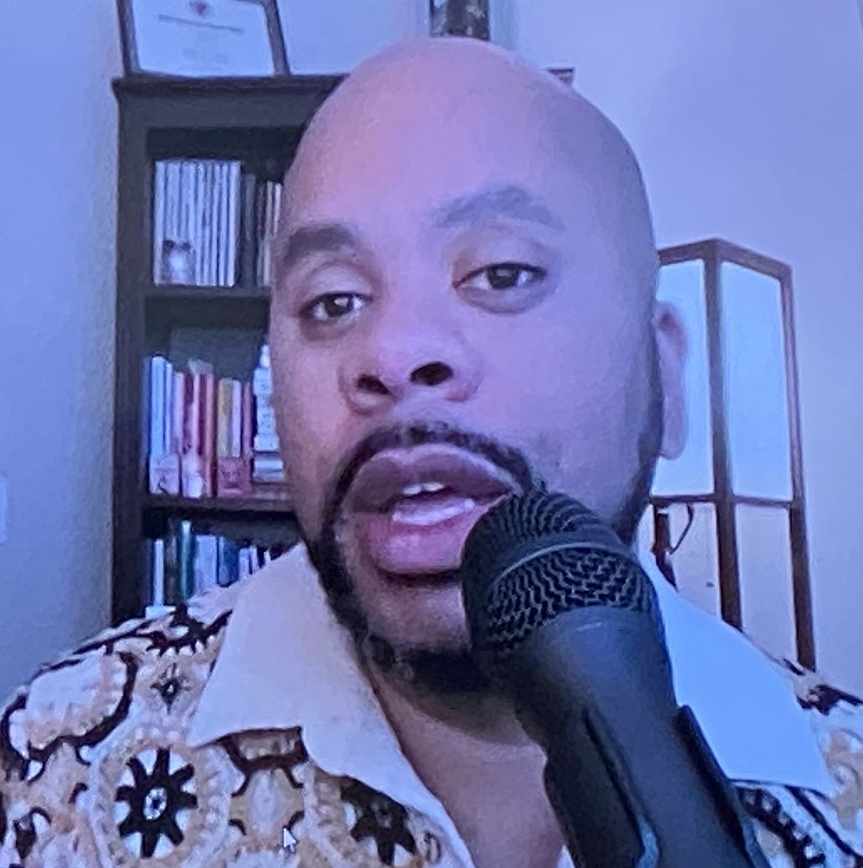The Friends and Patrons of the Maryland Library for the Blind and Print Disabled (LBPD) know that our library is great because of the staff and the opportunities that they create. Now, everybody else in the library community knows it too.
LBPD was recognized on July 18th as the Regional Library of the Year by the National Library Service for the Blind and Print Disabled, Library of Congress. This is a coveted award that libraries compete for throughout the country.
The ceremony took place at the Library of Congress in Washington, DC on July 18, 2024. Each nominee was rated on the following categories: mission support; creativity and innovation; patron satisfaction with the services, as well as a profile of the library.
Highlights of LBPD include providing 680,000 materials to the over 7,000 people served by the library. Additionally, 141 patrons were provided with Bookshare accounts, which amounted to 3,349 items being downloaded from Bookshare. Finally, the library recorded 300 locally produced books about Maryland and by Maryland authors and made them available on the Braille and Audio Reading Download (BARD) service, making them available to the rest of the country. The Friends are proud to highlight the incredible library staff on pages 4-6.

Spreading
the
Joy
of
Reading

Contact Us:

Friends of MDLBPD
672 Old Mill Road, #128
Millersville, MD 21108

friends@friendsmdlbpd.org

Friend us at:

www.facebook.com/lbph
friends

We’re on the Web!

http://friendsmdlbpd.org

Come One, Come All!
Annual Friends Meeting

The Annual Meeting will be held on Saturday, October 25, 10:00 AM. Our guest speaker will be John DeDakis, an award-winning novelist, writing coach, and manuscript editor from Maryland. He was a senior editor on CNN's "The Situation Room with Wolf Blitzer" and also served as a White House correspondent.

As the author of six mystery, suspense, and thriller novels, John regularly leads writing workshops at literary centers and writers’ conferences. He is also the host of the video podcast “One-to-One with John DeDakis” on YouTube, Facebook, and LinkedIn.

Originally from La Crosse, Wisconsin, John now resides with his wife, Cindy, in Baltimore. In his spare time, he is a jazz and rock-and-roll drummer.

John DeDakis is an excellent speaker and has many fascinating stories to share with us. He will also be happy to answer questions from the audience.

Please reserve your spot for this very special event!

October 25 at 10:00 AM.
At the meeting, you will also hear the latest “happenings” at the library, as well as the opportunity to make connections with fellow patrons and various library staff members. A complimentary lunch will be served.

Reservations:
Call 410-230-2424 and press 4
or: Send an email to reference.desk@maryland.gov

Reservations are required by October 17. When you contact us, please say whether you will be attending in person or on Zoom.

What’s Happening?

Friends support several of the following library activities and initiatives.

- The Friends voted to support Bookshare with 150 memberships. (See the article about Bookshare in this newsletter)
- John Owen reported to Friends that the new exterior sign has been installed on the building. It is a large dark metal rectangle with white lettering which stands out beautifully. It’s quite elegant!
- There is a new user-friendly, larger bench in the lobby.
- Inactive patrons are being personally contacted to encourage continued use of the Library services.
- The Tech Services Department is the next area to undergo renovation.
- The 2025 summer Reading Club activities took place over the summer with the theme ”Color My World.”
- The Library hosted its second annual virtual hike. (2025 was the Hundred Acre Woods, 2026 will be Mexico.)
- ​The Library will host a Dyslexia summit on October 16, 2025. Registration will be available on the Maryland State Library Agency website soon.
- Other activities/events that took place included a Dementia Webinar, Tactile Tours of Maryland Nature Museum, a Guinness Brewery tour, and Financial Literacy Webinars.
- The Enoch Pratt Free Library and State Library Resource Center’s (SLRC) Spring Conference is an annual conference for library workers throughout Maryland. In cooperation with the Maryland State Library for the Blind and Print Disabled (MD LBPD) and the Maryland State Library Agency’s (MSLA) Inclusion & Accessibility, Community of Practice, SLRC hosted training sessions, activities, and camaraderie with guest speakers from in and out of Maryland libraries, and colleagues from throughout the state. This year the conference focused on the theme of Disability, Inclusion, and Accessibility in Libraries (DIAL). Our own LaShawn Myles ran the conference.

Great News!

The Library partnered with the Baltimore Banner this year to promote the Liibrary’s services. Paid for by the Friends, the Library and the Banner sent out an email blast and ran banner ads on websites. Thus far, they’ve seen a significant return on investment, with an average click-through rate on banners of nearly 3.5% and an email open rate of approximately 36%. This is significantly above the national average for materials that fall under the category of "education." From April 30 to July 1, the Library's webpage received 6,124 visits, representing a 6.7% increase in traffic compared to the same period the previous year. The Library continues to produce a monthly podcast, LBPD Guest Hour, and posts itsTechnology User Group (TUG) meetings as podcasts.

Is There an Artist in the House?
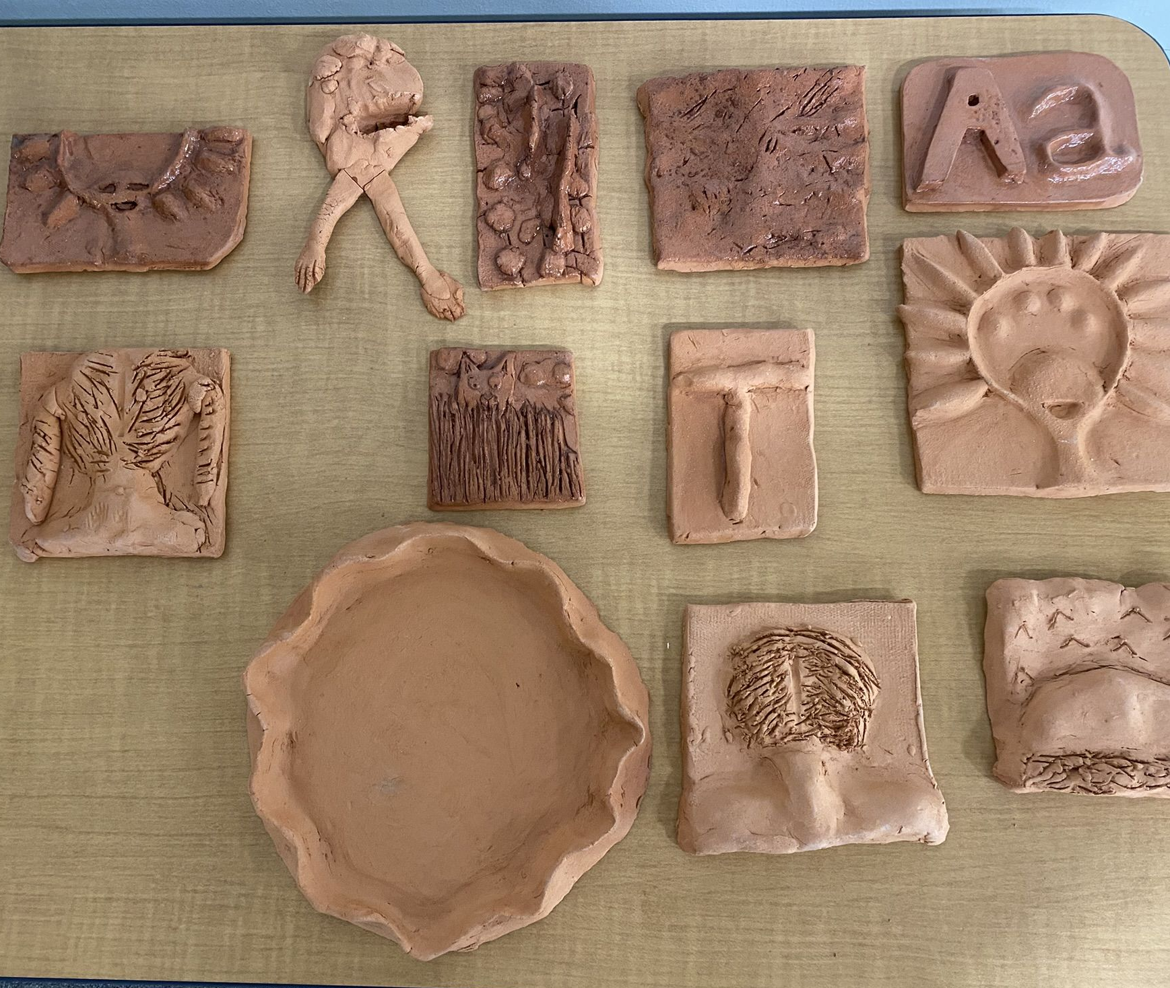
Baltimore Clayworks hosted a tactile educational experience for library patrons, including instruction on hand-building coils and pinch pots. The experience included clay samples in various states for the participants to touch. An Instructor representing Baltimore Clayworks taught up to 20 students, ages 8 to dult, on Friday, March 28, from 12:00 p.m. to 3:00 p.m. at the Maryland State Library for the Blind and Print Disabled.

What is Bookshare?

Bookshare is an online library of accessible e-books for people who have difficulty reading traditional materials due to print disabilities.
Bookshare provides alternative formats in:
- Epub
- Daisy
- Braille refreshable format (BRF)
- MP3
- Microsoft Word
Contributions of books by publishers and others, have resulted in a library of more than 900,000 books.
The Friends of LBPD pays for free memberships each year to patrons, and 116 users have now downloaded more than 6000 items.
Spotlight on Friends: Introducing Robyn Hughes

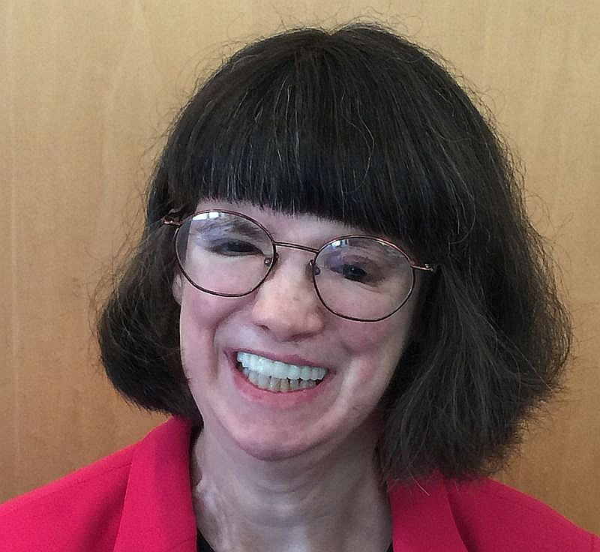
Friends Board Member Robyn Hughes recently completed her work as a reviewer/editor of the audio described White House visitor’s tour guide brochure through the University of Hawaii Communications Department, National Park Service and American Council of the Blind Descriptathon 11 collaboration, which is an annual 3-day virtual event with 2-months of pre-Descriptathon team preparation activities, that typically involve approximately 150-team members representing NPS staff, professional audio describers and several low vision/blindness community organizations based in and outside the US spread across 16-teams.
Each year, the participants are assigned to new park teams. And, this year, Robyn had the tremendous privilege of being selected to be a White House and President’s Park Team Member.
Robyn’s academic/professional background that prepared her for this position, includes being an American Council of the Blind-Audio Description Institute trained Audio Description Specialist, an Intro to Ballet Instructor for the Maryland School for the Blind Outreach Department and prior to the pandemic serving as a Museum Educator/Docent at the Jewish Museum of Maryland, for 15 years in addition to having an MA in German Jewish History from Baltimore Hebrew University and a BA in Jewish Studies from the University of Maryland, College Park along with having been a visiting graduate student at Harvard University and at Hebrew University in Israel.
Robyn is a lifelong audio description consumer. She holds MA, CNIB UEB Certified
ACB-ADI Trained Park and Ballet Audio Description Specialist certifications.

To view the White House’s Audio Described Visitor’s
Tour Guide Brochure:

- Download the free UniDescription App from the Apple App Store (Apple IOS device) or Google Play Store (Android device)
- Type White House in the App’s search box.
- The White House brochure link will appear below the search box.
- After you click on it , you can choose to read the text or listen to the audio version of it. If you don’t have access to a smartphone, there should be an iPad available (upon request) at the White House Visitor’s Center.

Upcoming Events/Dates

Intro to Ballet for Blind and Low Vision Participants
Saturday, August 23, 2025 at 11 a.m.
415 Park Ave., Baltimore, MD 21090
Registration required (In-person class)
Taught by experienced dance instructor Robyn Hughes, this introductory ballet class focuses on body awareness, graceful movement, and creative expression. No prior dance experience is needed, just the ability to move your arms and legs comfortably.
Hikeathon
October 5, 4:00 PM
Hilton Area of the Patapsco State Park in Catonsville

This Friends fundraiser is held every fall on a late afternoon and is facilitated by Friends Board member Robyn Hughes. Friends and their families gather to experience the Braille Trail there, a barrier-free and completely accessible pathway where hikers can learn about what grows in the park, read the Braille signage, play on outdoor musical instruments, smell herbs growing in raised beds, and listen to birds and other small animals scampering through space. Sometimes a Park Ranger will accompany the group and explain what’s happening along the trail. After walking through the trail, participants then enjoy a picnic dinner at one of the benches scattered around the area. It’s always a fun event! There’s plenty of parking and the Hilton Area is easy to find. We hope you can join us!

Staff Appreciation Day
September 26

The Friends of LBPD yearly celebrate the staff and all they do for the many patrons of the library by giving them either breakfast or lunch on a Friday in September, complete with prizes, gift cards, games, quizzes, sometimes revolving around a theme. Executive Assistant Cynthia York plans this with input from Friends and supplies a sheet cake, food, supplies, decorations, and many other items to make this a really fun event! Friends of LBPD are always on hand to help and participate in recognizing all the ways the staff work hard to make the library one of the tops of the year!

Tug Schedule

The Technology User Group at the Library for the Blind and Print Disabled is facilitated by Jerry Price and is an informal discussion group that meets to explore new technologies and services that assist people who are blind or print-disabled or older applications that have new functions that assist in the nonvisual arena. People of all technological skill levels are welcome. Meetings are held virtually via teleconference.

Here’s what’s coming up:

August 9: BARD 2.0

September 27: What to expect with iOS 19

October 11: What's new in Fusion and How to Use it with Vispero

November 8: AT Gifts for the Holidays
- ​​December 13: Wearables - is the price worth the benefit
Interested? Contact Jerry Price

(410) 230-2446

email jerry.price1@maryland.gov​

Contact us:
friends@friendsmdlbpd.org

Browse our site:
http://friendsmdlbpd.org

Friend us at:
www.facebook.com/lbphfriends

