Friends of MD State Library for the Blind and Print Disabled

Spring 2026

The Friends Bulletin

LBPH’s Talented Youth Services Librarian, Lori
in Montgomery County is an example of her creativity. The event was for young budding scientists and/or all children who like making a mess. Lori read the book, and led the group as they made multi-colored Oobleck, a substance resembling play-dough. Check out the photos to see some of the beautiful creations at this event.

A Message from
Friends President Melissa Riccobono
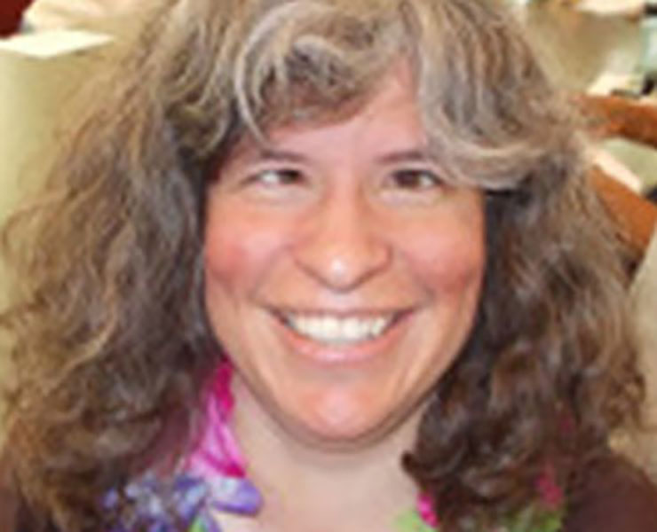
Spring is a season for new beginnings, and I am thrilled and honored to be writing my first message to all of you as the President of the Maryland Friends of the Library. First, let me thank both Sharon Maneki and Barbara Cheadle for their leadership as officers of Friends over the past several years. Both of you helped Friends grow and provided expertise and energy which allowed us to assist the library in completing many projects which will benefit patrons for years to come. We are so grateful both of you remain on our board; we will be seeking your guidance often!
I have been a member of the Friends board for several years, and a library patron, both in Maryland and Wisconsin, since I was a very young child. It gives me great joy to lead this organization and to be a place the library staff can usually get a “yes” when they come up with new ideas, instead of the “no” they may receive from other places.
I look forward to helping with projects throughout the year, and hope anyone interested in Friends and the work we do will take the time to be in touch.
I may be the official “captain” of this team, but it is because of the other board members and the way we all work together that things get done! So, thank you to the board and thank you all for your interest in the Friends.

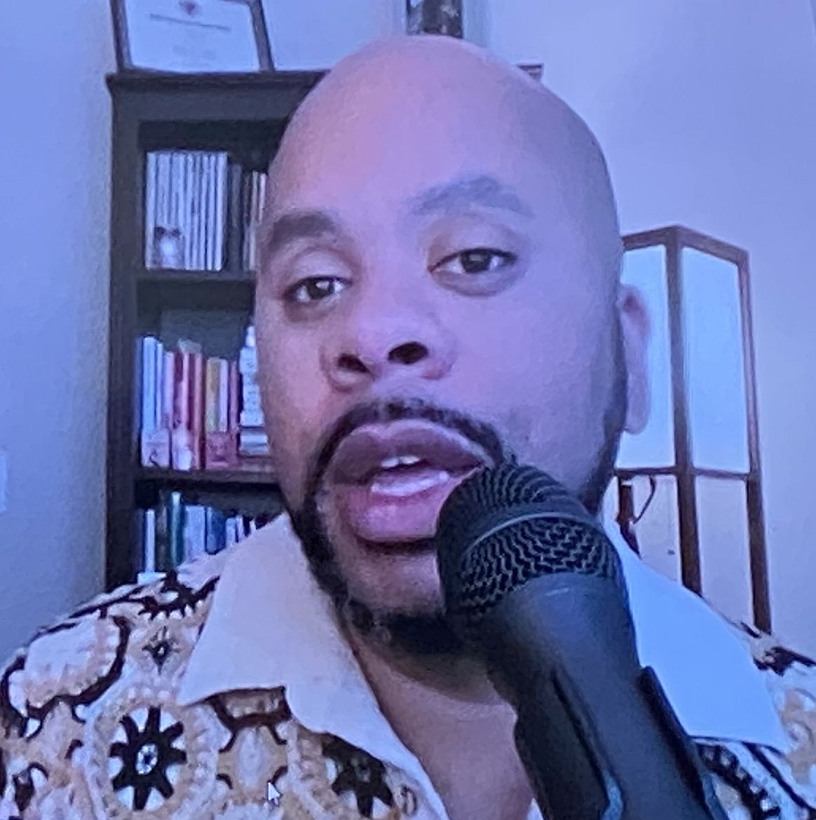The Friends and Patrons of the Maryland Library for the Blind and Print Disabled (LBPD) know that our library is great because of the staff and the opportunities that they create. Now, everybody else in the library community knows it too.
LBPD was recognized on July 18th as the Regional Library of the Year by the National Library Service for the Blind and Print Disabled, Library of Congress. This is a coveted award that libraries compete for throughout the country.
The ceremony took place at the Library of Congress in Washington, DC on July 18, 2024. Each nominee was rated on the following categories: mission support; creativity and innovation; patron satisfaction with the services, as well as a profile of the library.
Highlights of LBPD include providing 680,000 materials to the over 7,000 people served by the library. Additionally, 141 patrons were provided with Bookshare accounts, which amounted to 3,349 items being downloaded from Bookshare. Finally, the library recorded 300 locally produced books about Maryland and by Maryland authors and made them available on the Braille and Audio Reading Download (BARD) service, making them available to the rest of the country. The Friends are proud to highlight the incredible library staff on pages 4-6.

Spreading
the
Joy
of
Reading

Contact Us:

Friends of MDLBPD
672 Old Mill Road, #128
Millersville, MD 21108

friends@friendsmdlbpd.org

Friend us at:

www.facebook.com/lbph
friends

We’re on the Web!

http://friendsmdlbpd.org

The Annual Meeting on Saturday, October 25, 2025

The annual meeting opened on a beautiful sunny morning as the Friends, patrons, and library staff assembled in the library meeting room for the festivities. Sharon Maneki, President of Friends, ran the meeting.
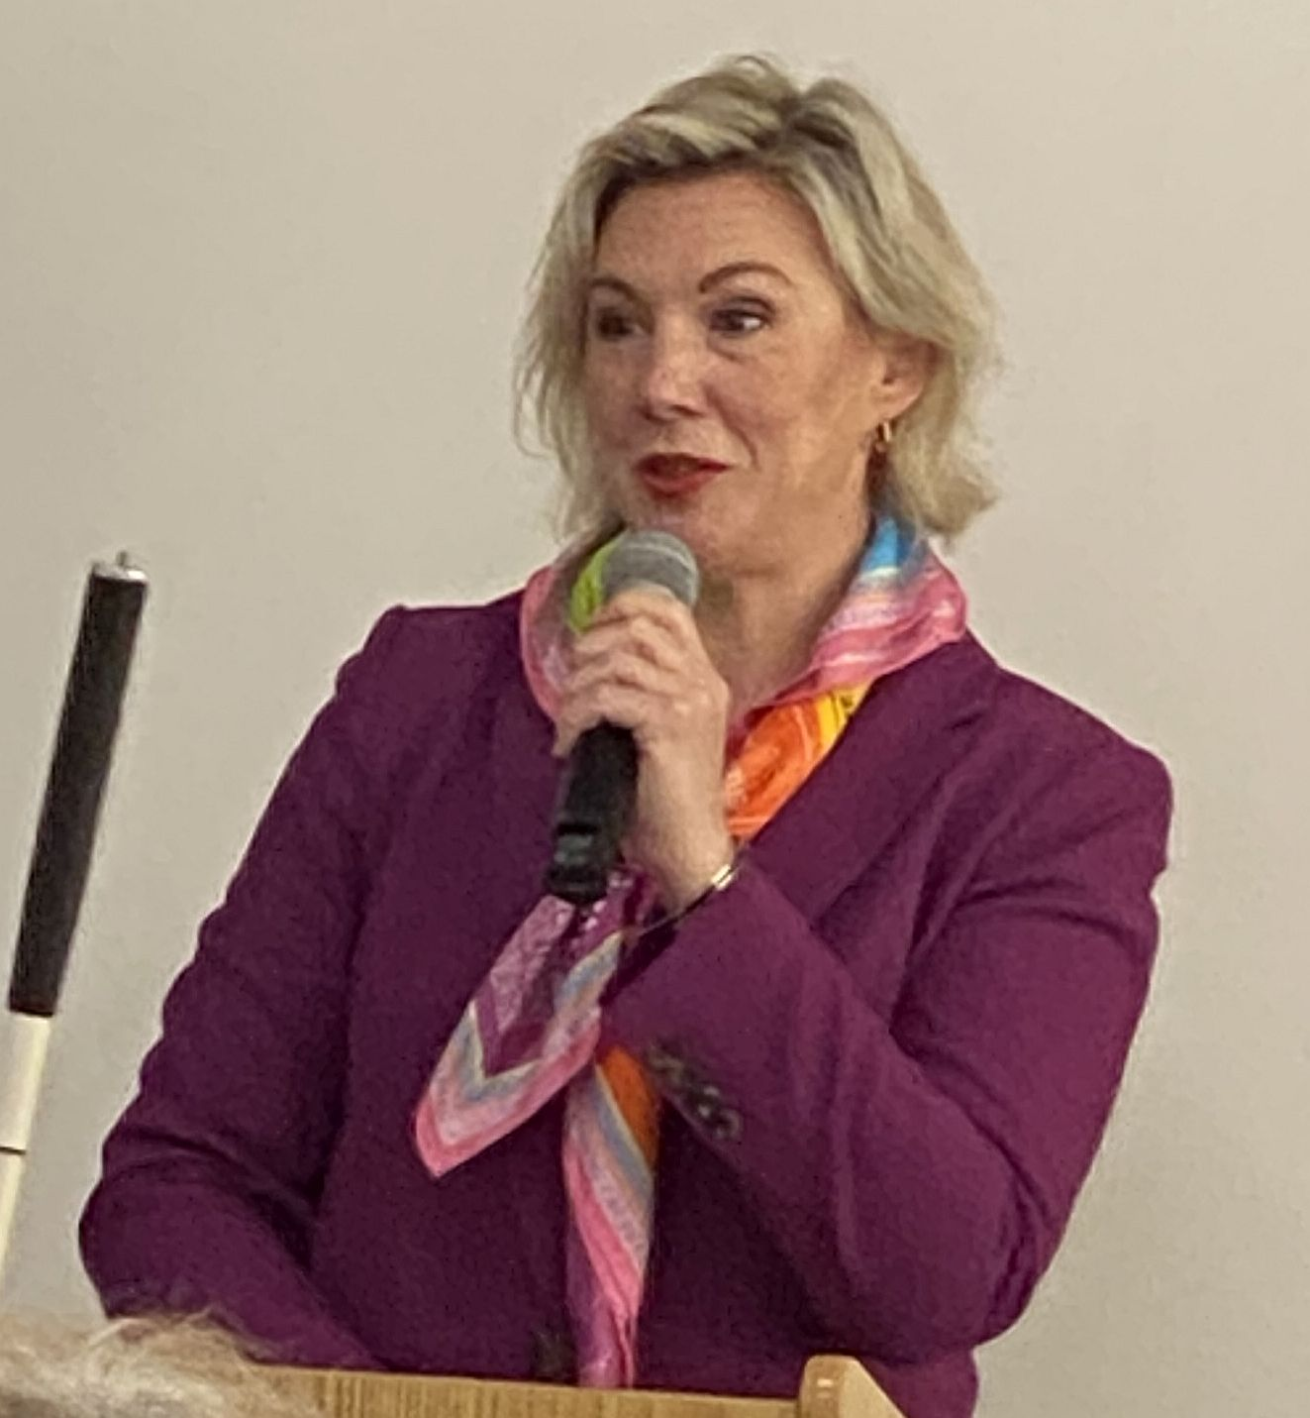
State Librarian Morgan Miller expressed her appreciation for the hardworking library staff and how proud she is of the Library’s rising circulation and outreach events. She highlighted two staff members’ accomplishments, Jerry Price and Ashley Biggs. Morgan also spoke of the upcoming building renovations, energy conservation efforts. and cost-cutting measures. She complemented Friends on their support for these items, as well as the new carpeting, exterior signage, and the new lobby bench which are already installed. She mentioned funding discussions at the State level in Annapolis and assured everyone that the Library funding is secure.

Elections to the Friends Board were presented by Melissa Riccobono, election chair. Three new members were elected to fill current vacancies, Gary Legates, Janice Samuel, and Gina Fugate. (Please note: A fourth new member was voted in at a subsequent meeting.)

In 1996, the Friends of the Maryland State Library for the Blind and Print Disabled established the Estelle B. Williamson Award to honor this dedicated advocate of Braille literacy. This award advances Braille literacy by use of technology, education, training, and innovation in all aspects of the use of Braille. This year’s winner is new Friend Gina Fugate, a computer science and technology teacher at the Maryland School for the Blind. In June, she used her award to do a presentation at the 2025 Tactile Reading and Graphics International Conference in Amsterdam. Her presentation on the main stage was entitled: Multimodal Approaches to STEM: Combining Braille Displays and Robotics for Accessible Learning. She explained how innovative tactile reading technologies such as combining tactile graphics, 3D models, multi-line Braille, and sensory feedback empower blind students in mainstream education.

Gina described her inspiring experience which included meeting Braille advocates and innovators from all over the world, visiting the Anne Frank house and museum to see a 3D touch activated model of the house, tasting international cuisine. She even ate Braille chocolate!


Keynote speaker, John DeDakis, took the podium praising the high spirits in the room and charming everyone by telling a few good jokes before launching into his topic: “From Journalist to Novelist, or How I Learned to Start Making It Up.” He began by telling his engaging backstory, spending 45 years in journalism (25 of them as a senior copy editor on CNN and working on The Situation Room with Wolf Blitzer), interviewing Alfred Hitchcock, Jimmy Carter, and Ronald Reagan among others, and teaching journalism at the University of Maryland and the American University in Washington DC. He currently teaches novel writing online and speaks at literary centers, writers’ conferences, and bookstores. He is the author of six Lark Chadwick crime novels and is currently working on a memoir. In a personal, humbling, and endearing manner he spoke about where he draws his inspiration. He recognized that, after undergoing grief counseling following the death of his sister and his son, that fear is a powerful component in the healing process and how to harness and deconstruct it. After rousing applause, he took questions from the audience, most asking how to get published themselves. Everyone agreed that he gave great advice, and was a thought-provoking and entertaining speaker!

After these wonderful presentations, we had a lovely lunch and enjoyed each
others’ company!
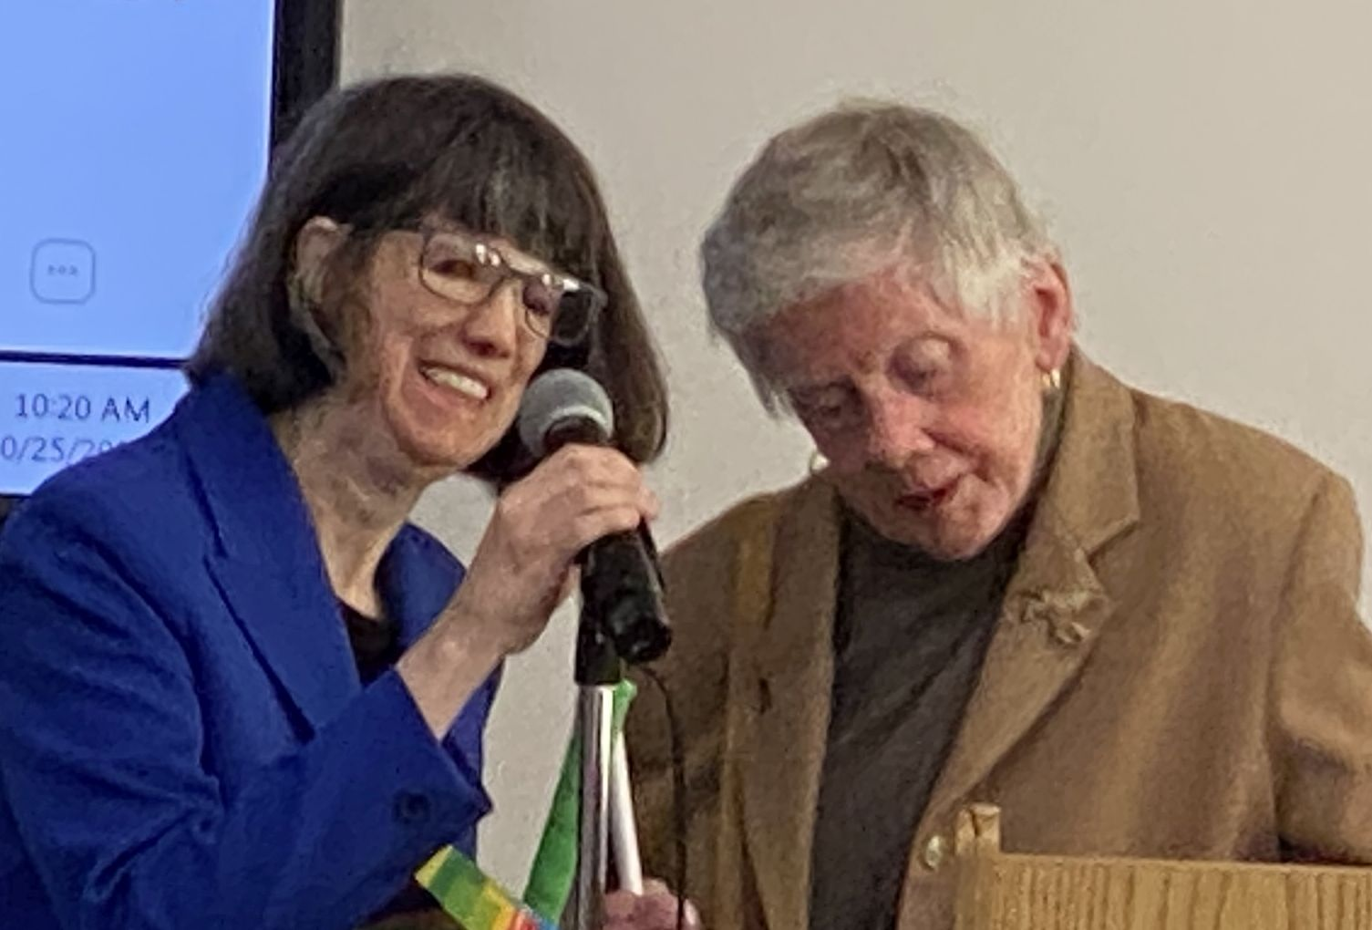
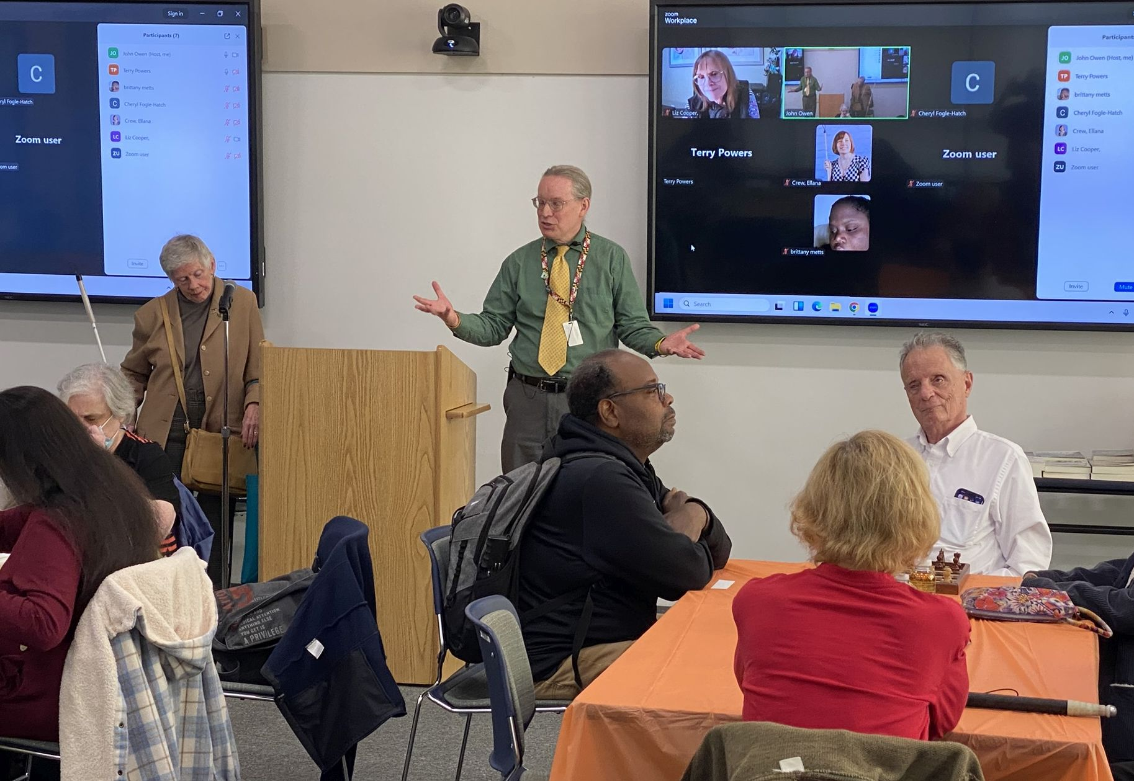
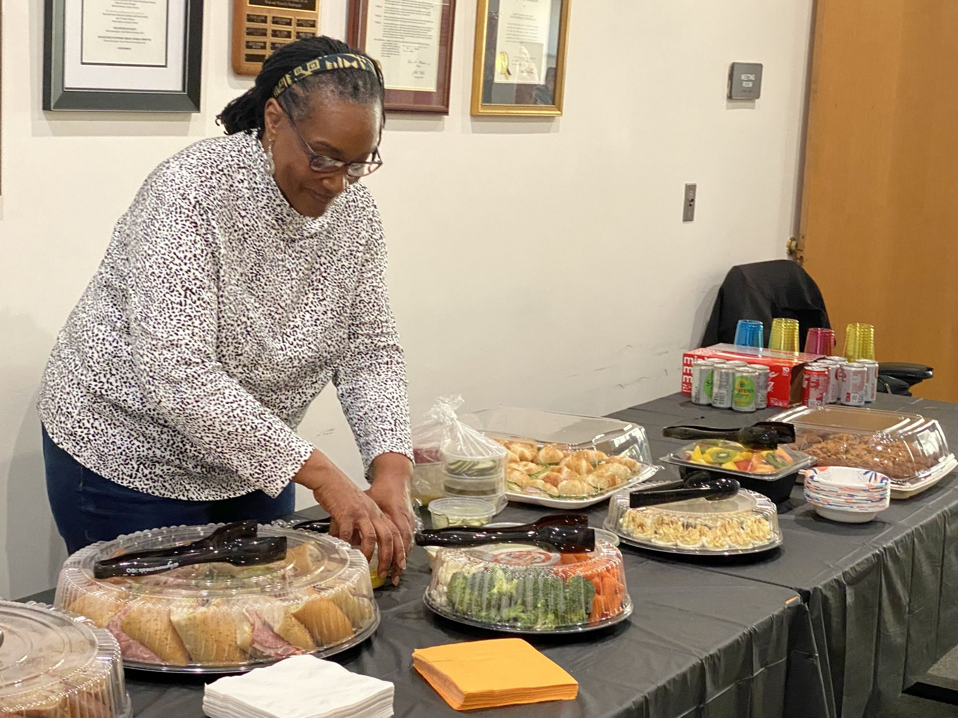

Great News!

Maryland Matters is on Newsline

The Friends Board approved to advance money to support Maryland Matters on Newsline. Maryland Matters is a non-partisan and non-profit news site that relies on contributions from readers and organizations and covers issues in the State House in Annapolis. It is now part of NFB-Newsline and available on the web as a mobile app, and also for Digital Talking Book Players as well as other devices for blind and print-disabled. To get NFB Newsline, LBPD patrons can call the library Information Desk at 410-230-2424 or 1-800-964-9209 and request an application. Maryland Matters is part of States Newsroom, the nation’s largest state-focused free news organization.

Outreach Librarian Ashley Biggs wins the 2025 V. Eugene McCrary Award from the Maryland Optometric Association

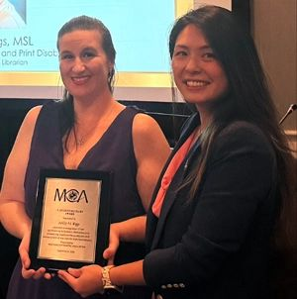
The Maryland Optometric Association protects doctors and their patients by educating, promoting, and advancing the practice of optometry in the state of Maryland. At their annual membership meeting on September 6, 2025, they named Marketing and Outreach Librarian, Ashley Biggs, the winner of the V. Eugene McCrary Award. This award annually recognizes someone outside the optometry profession for substantial contributions to the advancement of eye care for Maryland residents. Former US Senator Barbara Mikulski also once won this award, which is named for a former president of the Maryland Optometric Association, V. Eugene McCrary. The
Friends of the Maryland State Library for the Blind congratulate Ashley for this recognition and for fostering a partnership with this vital Maryland voice of optometry.

In addition, Ashley did a spectacular job, coordinating the Dyslexia Summit on October 16th, 2025. She presented, and assembled all the contributors, and initiated many other community engagements. Congratulations, Ashley!


Congratulations, Jerry Price

Jerry Price, the Accessible Technology Education Program Coordinator, was 2025 winner of the Pride Award, given by the Maryland State Board of Education. He was also named the Digital Equity Champion by Marylanders Online. Jerry Price oversees the Maryland Braille collection and trains and instructs the blind and low vision community in the use of accessible technologies through his Technology User Group (TUG) events. In 2025 he was awarded the Pride Award from the Maryland State Board of Education for helping individuals achieve independence through the mastery of ever-changing assistive technology.
Marylanders Online awarded Jerry a 2024 Maryland Digital Equity Honorable Mention award for his outreach work through his TUG events and demonstrations of new tech news and trends. He advises a team of volunteers who help him investigate new ways of access from a blind person’s perspective.
Congratulations, Jerry, for all you do to help Maryland residents navigate this challenging technology.

TUG

The Technology User Group at the Library for the Blind and Print Disabled is facilitated by Jerry Price. TUG is an informal discussion group that meets to explore new technologies and services that assist people who are blind or print-disabled. People of all technological skill levels are welcome. Meetings are held virtually via teleconferences.
Interested? Contact Jerry Price

(410) 230-2446
email jerry.price1@maryland.gov

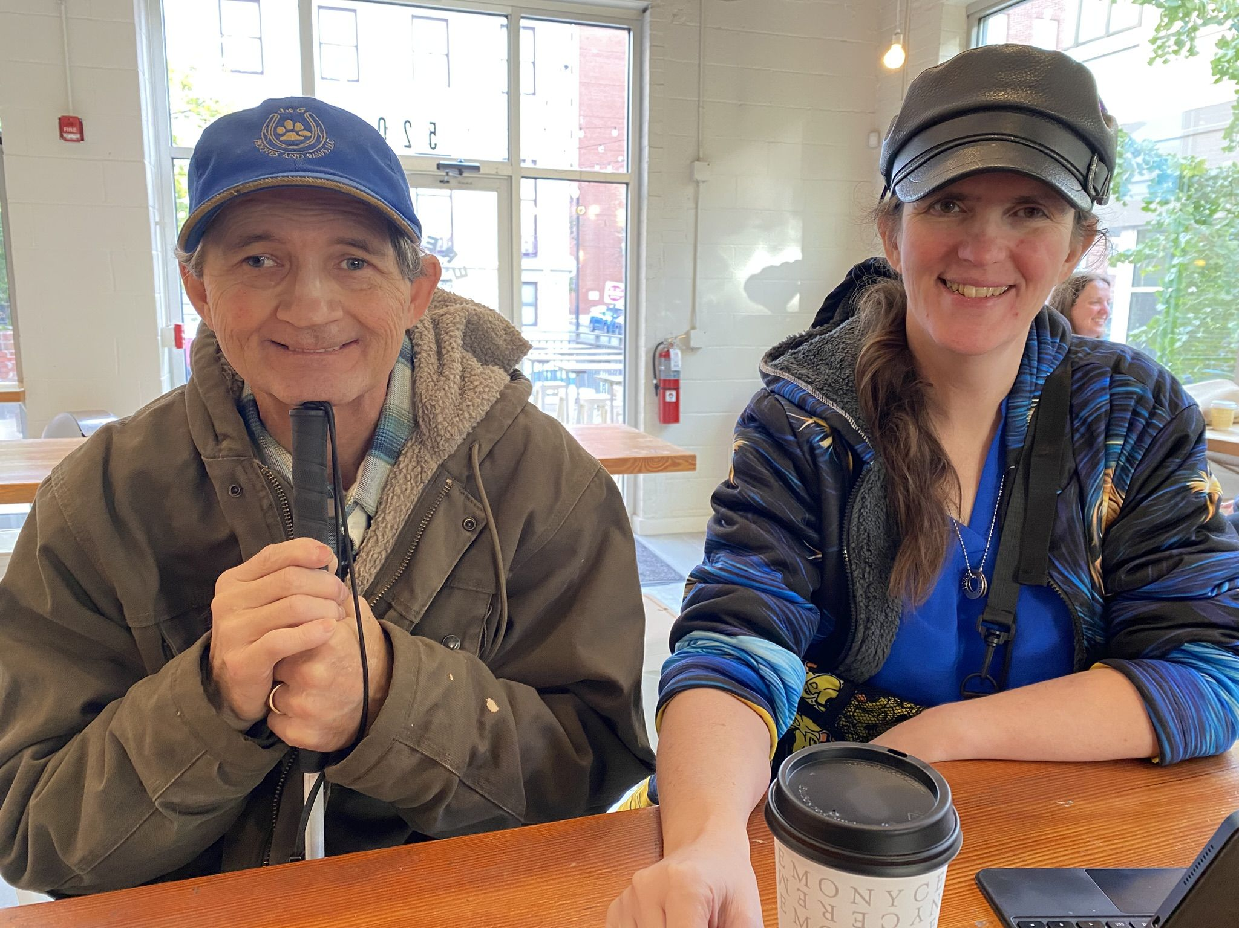

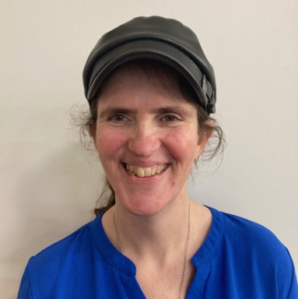
Make New Friends but Keep the Old!
After many years of dedicated service, President Sharon Maneki and Vice President Barbara Cheadle both stepped down from their leadership positions but will remain on the Board.

Four new Friends have joined the board: Gina Fugate(top), Left to right: Gary Legates, Janice Samuel, and Marla Migdal. Check out their bios on the Friends Website.

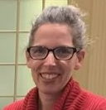
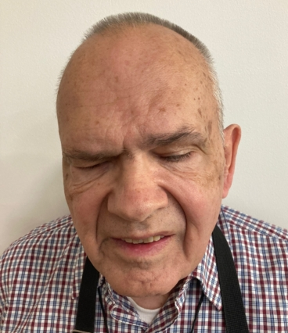
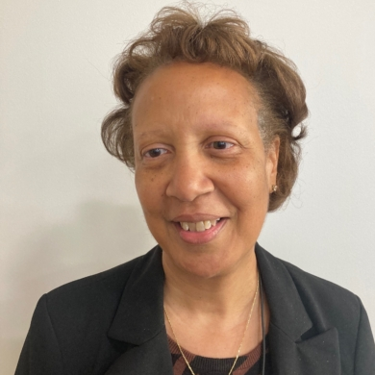

Friends is also losing a long-time friend, Robyn Hughes, who is stepping down to pursue some new exciting opportunities.

Melissa Riccobono will now serve as President and Janet Sanford will serve as Vice- President.

Mark your calendars!

You won’t believe the celebrity who is coming to speak to us at our next annual meeting!

Our special guest will be Dan Rodricks, local Baltimore columnist formerly with the Baltimore Sun and now writing for the Baltimore Brew and Fishbowl. He is also a playwright, and radio commentator for WYPR, and the author of three books.
Saturday, October 24, 2025 at 9:30 a.m.
415 Park Ave., Baltimore, MD 21090

The Downtown Partnership of Baltimore

Each spring, the Friends of the Library for the Blind and Print Disabled renew
the Library’s membership in the Downtown Partnership of Baltimore. The
Partnership is a group of individuals, communities, and businesses working
together to make a better Baltimore by organizing events, conducting outreach,
and promoting the city. If you have noticed people picking up trash and
planting flowers in large containers around public buildings, chances are they
are from the Downtown Partnership. They provide outreach services to the
unhoused, improve urban design and increase overall public safety.
They host events such as the Monument Lighting in Mount Vernon in December each year, Baltimore Restaurant Week, the Pratt Street Market and more. There are over 650 companies, both big and small, in Baltimore that are members of this beneficial city service. The Friends are proud to be part of this effort on behalf of LBPD to make Charm City the best it can be! To find out more about the Downtown
Partnership, check out their website at http://www.godowntownbaltimore.com

Annual Fall Hikeathon Planned for September

On Sunday September 27 at 4PM Robyn Hughes and Janet Sanford will host the Friends of LBPD annual Hikeathon fundraiser at the Hilton Area of the Patapsco State Park in Catonsville! This is always a fun event. We have beautiful early fall good weather for it, and it’s a nice walk in a peaceful leafy park with a Braille Trail filled with informational signs, outdoor musical instruments, birdhouses, and scented herb-raised beds for investigation. The roped-hike is accessible to all, and less than a quarter-mile loop. We usually go around it a few times and then convene at picnic tables nearby for a shared dinner. It’s a great way to get to know folks from the LBPD community and to contribute to the Friends of LBPD.
Upon arrival, the Ranger will direct you to the Hilton area. There is a $3.00 fee. If the light and the weather hold out, there are other trails and hikes throughout the park. Hope to see you there!

Friends of MDLBPD
672 Old Mill Road, #128
Millersville, MD 21108

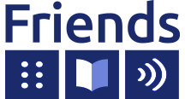
of the Maryland State Library
for the Blind and Print Disabled

Contact us:
friends@friendsmdlbpd.org

Browse our site:
http://friendsmdlbpd.org

Friend us at:
www.facebook.com/lbphfriends

