Friends of MD State Library for the Blind and Print Disabled

Fall 2026

The Friends Bulletin

LBPH’s Talented Youth Services Librarian, Lori
in Montgomery County is an example of her creativity. The event was for young budding scientists and/or all children who like making a mess. Lori read the book, and led the group as they made multi-colored Oobleck, a substance resembling play-dough. Check out the photos to see some of the beautiful creations at this event.

A Message from
Friends President Melissa Riccobono
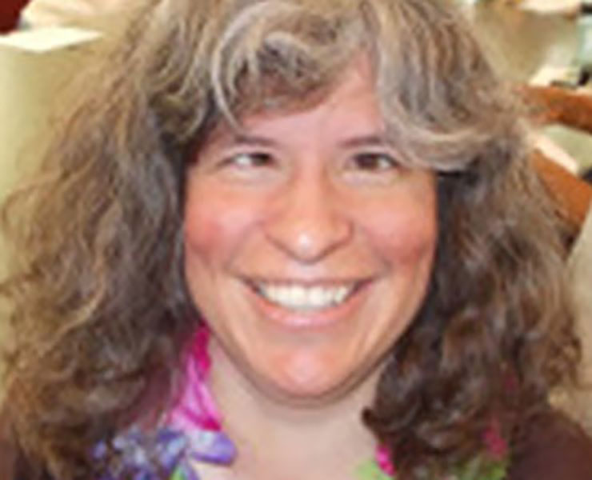

The month of October has become full of recognition for people with different disabilities. It is Disability Employment Month, Blind Equality Achievement Month, and
also Dyslexia Awareness Month.

When people hear about LBPD for the first time, the word they often focus on is “blind.” This makes sense, as our library provides Braille and audio materials for the blind. However, the library also serves many individuals who have physical disabilities which prevent them from holding a book, turning pages, etc., and people with print disabilities
including dyslexia.

I have begun exploring dyslexia personally since my middle daughter was diagnosed as dyslexic about a year ago. Unfortunately, as sometimes happens, she was not diagnosed until she was a sophomore in high school. I think about all of the times she struggled with reading, writing, and processing. I remember knowing there was something wrong but being told she had ADHD and nothing else.

We are pleased to present two articles about dyslexia in this newsletter. We hope you will learn more about dyslexia and share the resources of the MD LBPD with anyone you know who has trouble with reading. It is quite possible they qualify for library service, and we are waiting to welcome them so they can explore the joys of reading audio books for free, and all of the other things our library has to offer.

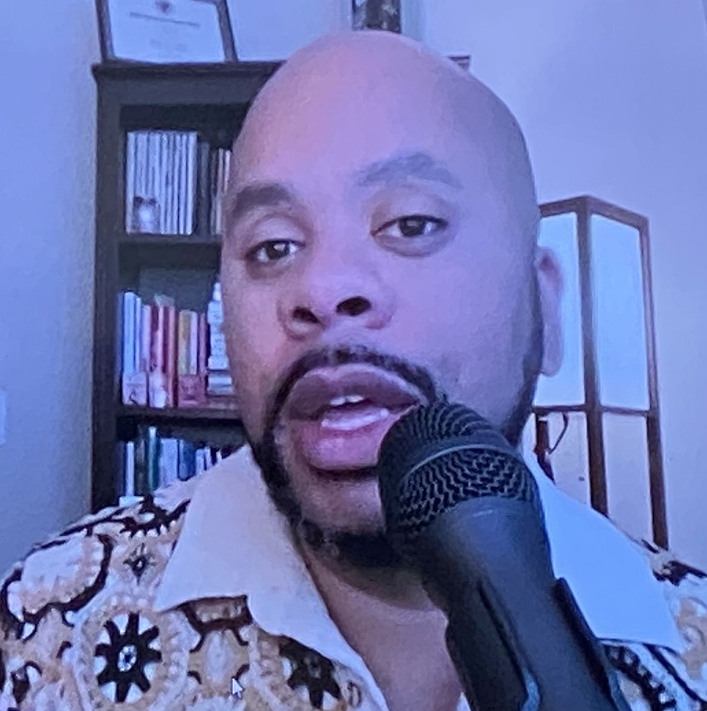The Friends and Patrons of the Maryland Library for the Blind and Print Disabled (LBPD) know that our library is great because of the staff and the opportunities that they create. Now, everybody else in the library community knows it too.
LBPD was recognized on July 18th as the Regional Library of the Year by the National Library Service for the Blind and Print Disabled, Library of Congress. This is a coveted award that libraries compete for throughout the country.
The ceremony took place at the Library of Congress in Washington, DC on July 18, 2024. Each nominee was rated on the following categories: mission support; creativity and innovation; patron satisfaction with the services, as well as a profile of the library.
Highlights of LBPD include providing 680,000 materials to the over 7,000 people served by the library. Additionally, 141 patrons were provided with Bookshare accounts, which amounted to 3,349 items being downloaded from Bookshare. Finally, the library recorded 300 locally produced books about Maryland and by Maryland authors and made them available on the Braille and Audio Reading Download (BARD) service, making them available to the rest of the country. The Friends are proud to highlight the incredible library staff on pages 4-6.

Spreading
the
Joy
of
Reading

Contact Us:

Friends of MDLBPD
672 Old Mill Road, #128
Millersville, MD 21108

friends@friendsmdlbpd.org

Friend us at:

www.facebook.com/lbph
friends

We’re on the Web!

http://friendsmdlbpd.org

MelissaARiccobono @ gmail.com
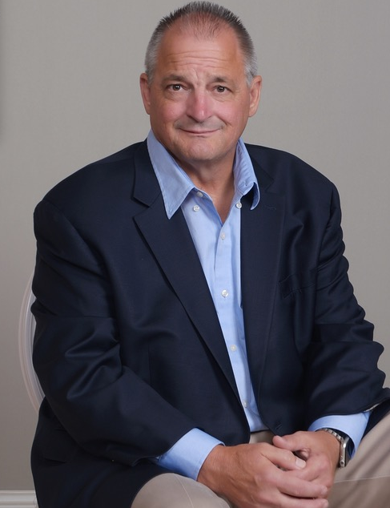
October is Dyslexia Awareness Month.
The goals are to educate the public, dispel myths, and celebrate the strengths of individuals with dyslexia.
This issue is dedicated to late
Friend of LBPD Gary Hawbaker, who struggled with dyslexia.

Image Gary Hawbaker
Dyslexia
By Marla Migdal
Certified Structured Literacy Dyslexia Specialist

According to the International Dyslexia Association, 15-20% of the population has characteristics of dyslexia. During the fall of 2025, the International Dyslexia Association (IDA), updated the definition to state, “Dyslexia is a specific learning disability characterized by difficulties in word reading and/or spelling that involve accuracy, speed, or both and vary depending on the orthography.” Orthography is the standardized system of writing a language, including the rules and conventions for correct spelling, punctuation, capitalization, hyphenation, and word breaks.

The term Specific Learning Disability is recognized by the US Department of Education through the Individuals with Disabilities Education Act (IDEA), the American Psychiatric Association and the World Health Organization. Dyslexia, Dysgraphia, and Dyscalculia all fall under the Specific Learning Disability category. In fact, as of 2015, The Department of Education wrote a “Dear Colleague” letter to school systems stating that they can use the term Dyslexia.

The characteristics of Dyslexia are not all the same from person to person. They can vary across severity and impact reading at the word level, fluency, spelling, and comprehension. Students struggle with a range of cognitive profiles and variance with the phonological processing systems.

Environmental factors and genetic differences are now included in the definition. In my case, I didn’t think I had a family history, but I was wrong. My father was held back and struggled in school. His parents were immigrants and had to leave school to work, so their learning history is unknown. However, as many as 49% of parents of kids with dyslexia also have it, and about 40% of siblings will also struggle with reading. Therefore, a family-positive history whether there is formal or informal collection of data needs to be added as a risk factor when determining identification of Dyslexia.

Dyslexia and ADHD can also co-occur between 25-40% of the cases and can be identified with one condition that exhibits characteristics of the other. Working memory weakness can overlap with ADHD and Dyslexia. Many students are identified with ADHD but not dyslexia and many that are under identified are students of color.

In 2016, the Maryland State Department of Education released a Technical Assistance Bulletin with a focus on Dyslexia, Dysgraphia, and Dyscalculia with guidelines for school systems to identify Specific Learning Disability and the importance of using the terms Dyslexia, Dysgraphia, and Dyscalculia. The bulletin stated, “There is nothing in Maryland law, policy, procedures, or practices that prohibits use of these terms dyslexia, dyscalculia, dysgraphia-by IEP teams as it relates to evaluations, eligibility, and IEP documents.”

Yet, ten years later, many counties across Maryland are failing to identify students with Dyslexia, and students are not receiving the appropriate support they need. The self-esteem of students is greatly impacted and many feel “stupid.” Both of my children have dyslexia and have expressed this throughout their journey.

As a family, we decided to advocate for the Ready to Read Act which supports early identification and provides requirements by school systems to screen kindergarten through third graders for reading difficulties. My daughter and son spoke in Annapolis, and this bill was passed in 2019. Early identification and intervention is key to reducing the learning gap. This was an important bill that needed to be passed, and many parents and educators advocated for it because numerous families can’t afford to pay for tutors or provide support with a private school. My son will be graduating from college this year with a focus on graduate school, while my daughter will be graduating from high school and will be applying to college. Accommodations are key for them in higher education in order for them to access grade level material. However, accommodations do not replace direct, explicit, multimodal, cumulative, and sequential instruction in phonics, spelling, and fluency.

To learn more about dyslexia, follow these links:

https://dyslexiaida.org/
https://www.understood.org
https://dyslexiaida.org

Visit our Friends of MLBPD Facebook page to read more about Marla’s personal journey as a parent and educator.
Meet Bella

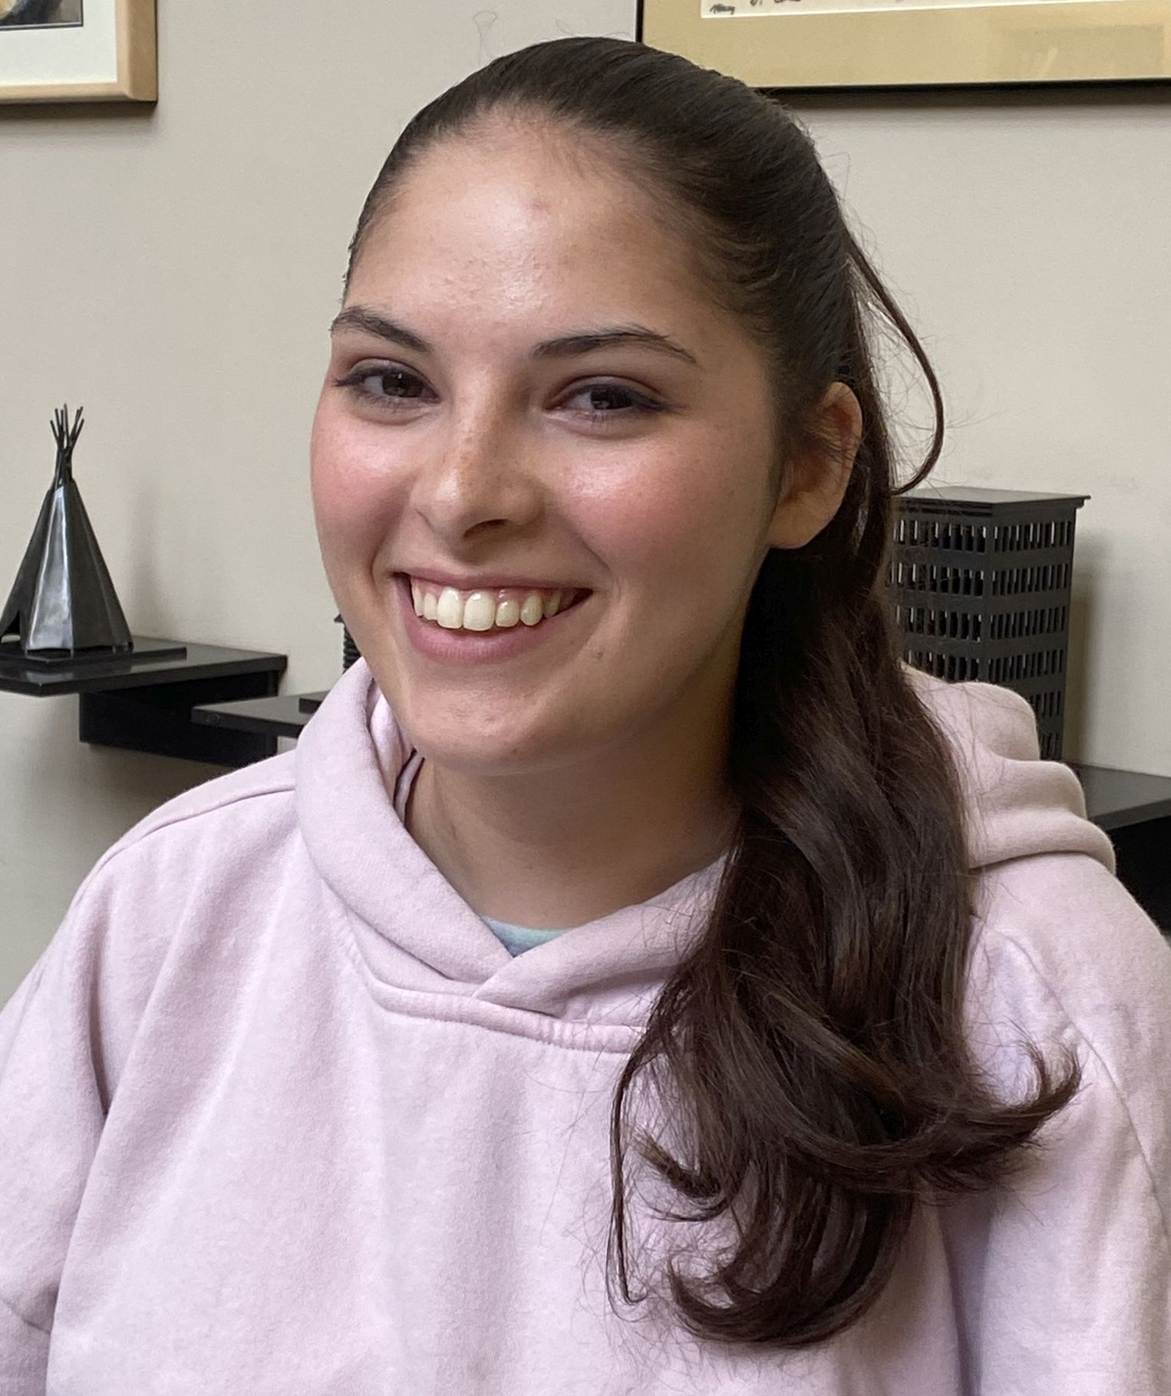
To meet and speak with this articulate teen, you would have no idea that she has the trifecta of invisible disabilities. Bella has dyslexia, dysgraphia, and ADHD. She is confident, smart, well-read, and at ease with herself and others, with aspirations of college and a career in physical therapy. But it wasn’t always this way. Bella is fortunate that her mother, Marla Migdal, had the experience, expertise, and persistence to advocate for her early in her life when it became apparent that she was struggling and balking at going to school.

Image: Bella
Her Journey
Difficulty in mixing up letters in words, number sequences and left/right directional commands became evident by the 3rd grade, confusing Bella and leading her to believe that she was different from the other students in class. She felt angry, stupid, and left
out, and hated school. No accommodations were given as she fell behind. Then, when her disabilities were finally recognized, Bella felt badly about being singled out, when she was summoned out of the room for “special help” in front of the other students. Problems persisted until Bella was placed in a school designed specifically for dyslexic/dysgraphia students, where she could form stronger relationships with teachers and get back on track.

Bella’s Advice to Struggling Students
“Immediately tell your parents and ask for help because the earlier these disabilities are discovered the more help will be offered. Find people to advocate for you. Look at social media to reassure yourself that many youngsters with a high IQ struggle with reading disabilities. Build strong relationships with reading teachers to assure that you will have all the accommodations you deserve. Accommodations can be allowing extra time to complete exams, having access to a spellcheck function, testing in a small room to cut down on distraction, having math problems read out loud for best comprehension. Seek out attractive books with good covers, because someone went to the trouble to make the book pretty, so it must be good, with large font and short chapters to encourage a sense of confidence and accomplishment.”

Bella is now an honor student, and is interning in her future career in PT.
UMBC Bookfest: Great Collaborative Event

Friends supported and attended the UMBC Book Fest in conjunction with the library staff on April 21st and 23rd. Director of LBPD John Owen and Friends President Melissa Riccobono were on hand to join the students and others in a celebration of writers, readers, makers, and advocates. On Tuesday, April 21st , in the UMBC Library, Plaza attendees enjoyed a book arts display, a demonstration of letterpress printing, zine-making, a book drive supporting the Maryland Commission on African American History and Culture, the Baltimore County Public Library Bookmobile, and bookish giveaways. Throughout the Bookfest, UMBC students raised $500 to support the Library for the Blind.

This year thus far, the Friends of LBPD supported the library by funding:

- Celebrating America’s 250 Years, June 15-July 17. This interactive program invited LBPD participants to explore key moments in Maryland history through a self-guided text-based game. Finishers received a completion prize.

- Unearth a Story Summer Reading Club. June 13-August 15. T-shirts and other prizes were distributed at select programs.

- Summer Reading Club special event, July 16th. Archaeologist Beth Pruitt presented a program exploring how archaeologists find and piece together the past. Dr. Pruitt provided artifacts, explained how to play an ancient Egyptian board game, and how to create an artifact out of clay.

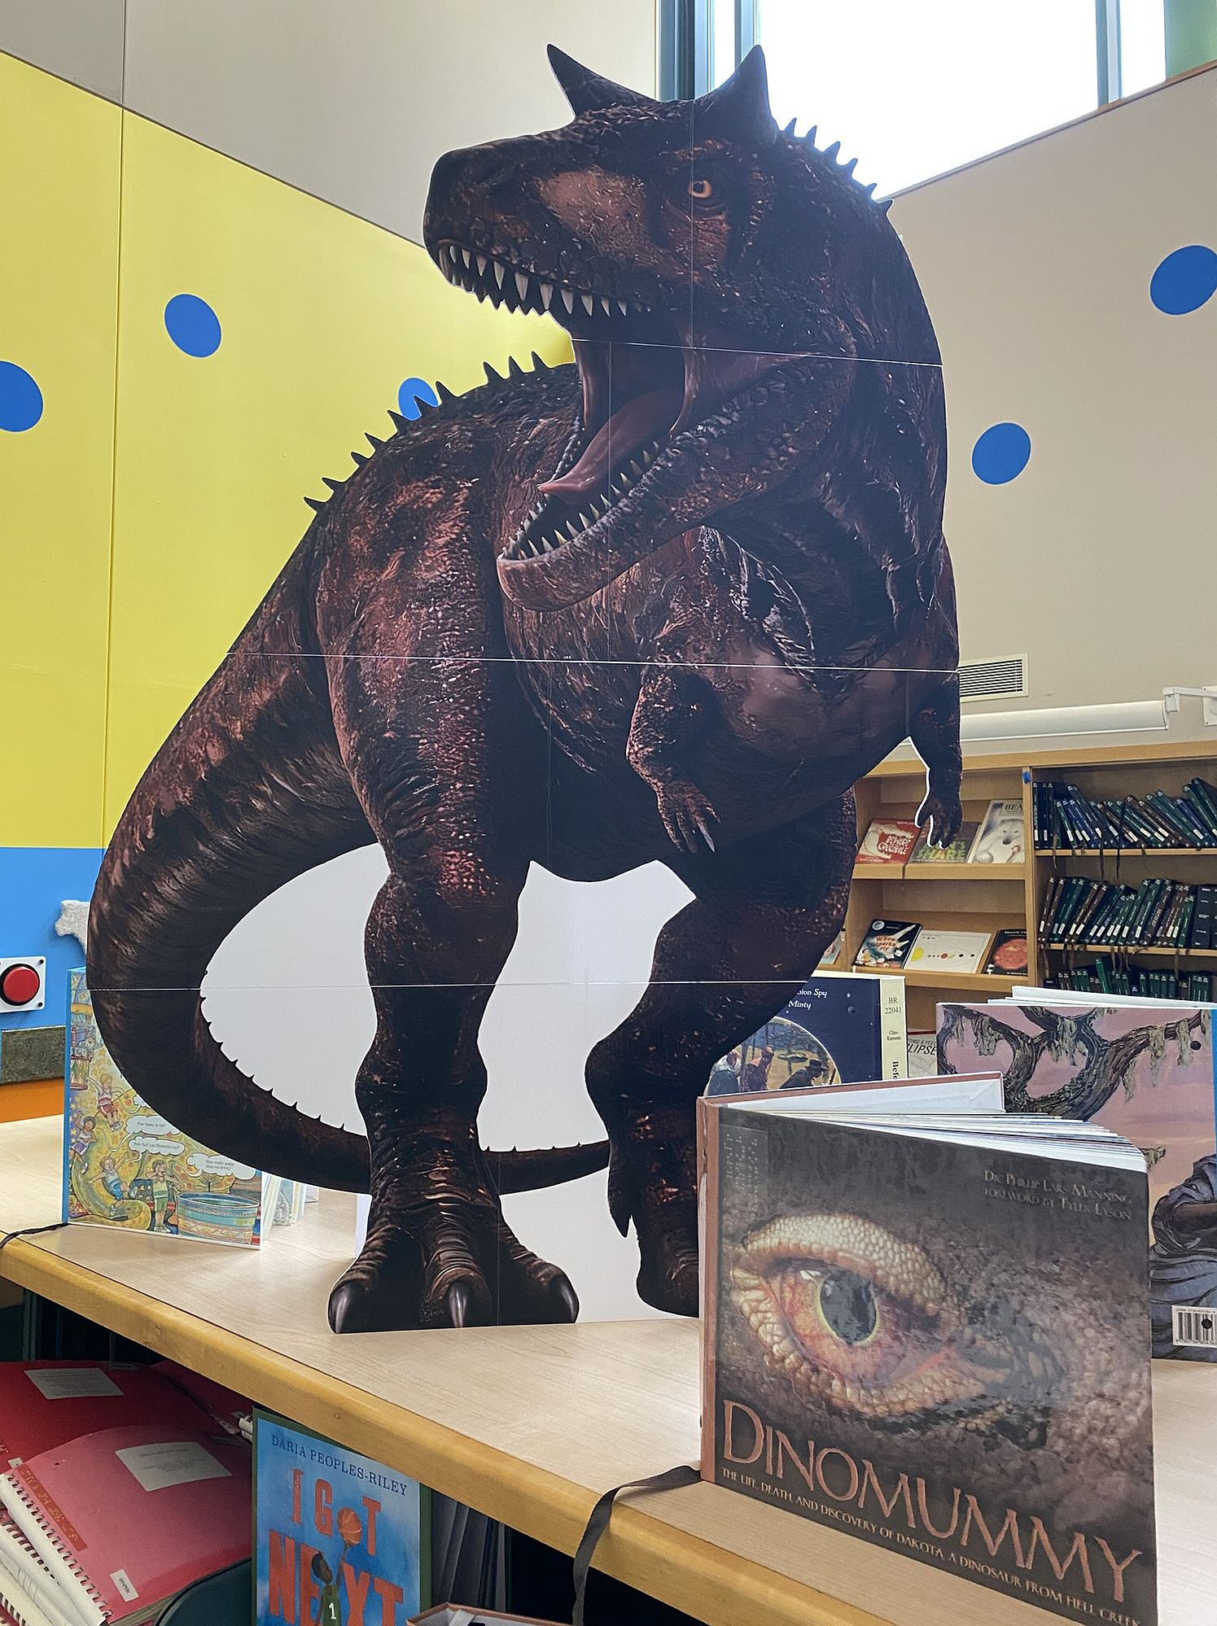
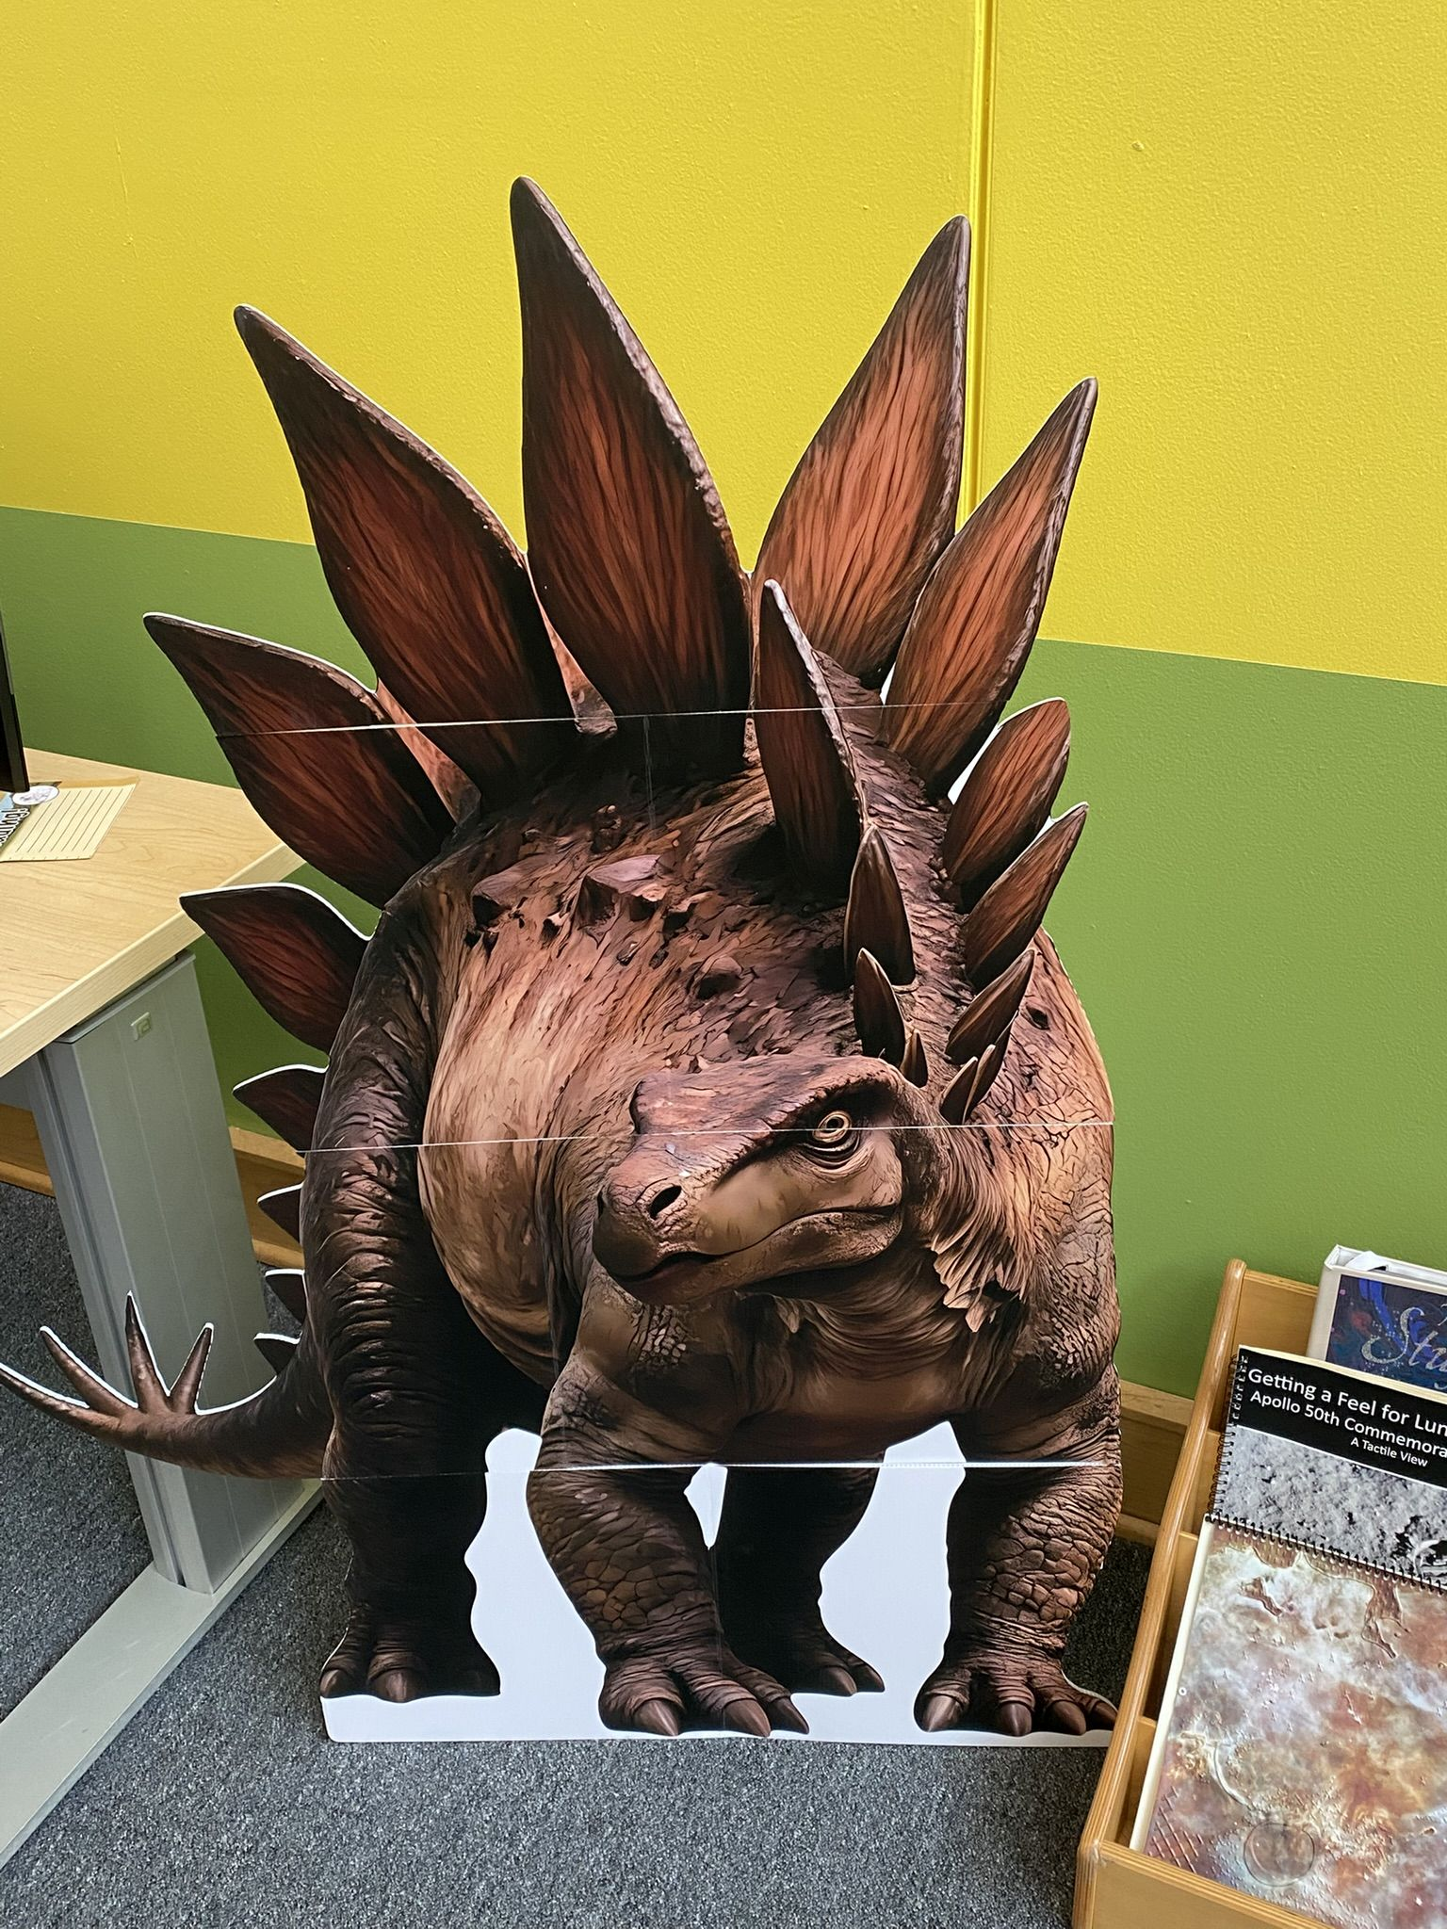
Images: Two large dinosaurs on display at Library

- Code in the Schools Program. This program was very successful, and each Braille Enrichment for Literacy and Learning (BELL) locations
- in Baltimore, Rockville, and Salisbury thoroughly enjoyed utilizing the tactile kits and learning about coding. The invoice covers the six kits for LBPD, Elissa's program, and travel expenses to each location. Thank you to Gina Fugate for working on this important event! LBPD now has six coding kits, and we hope to provide more coding programs in the future.

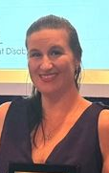
LBPD Outreach Librarian Ashley Biggs wins Another Award!

Last year Ashley (pictured in image) secured the V. Eugene McCrary Award from the Maryland Optometric Association, but she didn’t stop there. This year she was named a 2026 LJ Mover and Shaker! She joins fifty other library professionals in the US to earn this prestigious award. The May 2026 issue of Library Journal showcases all the winners.
Director of LBPD John Owen had this to say: “Ashley cares about the community we serve, and it shows in each connection she makes with a patron, a caregiver, or a professional. She brings a real joy to her work and to the people around her.” The Friends of LBPD are proud to support Ashley Biggs and her innovative outreach and programming successes! Way to go, Ashley!

2026 Virtual Hike: Mexico
Image- Medals
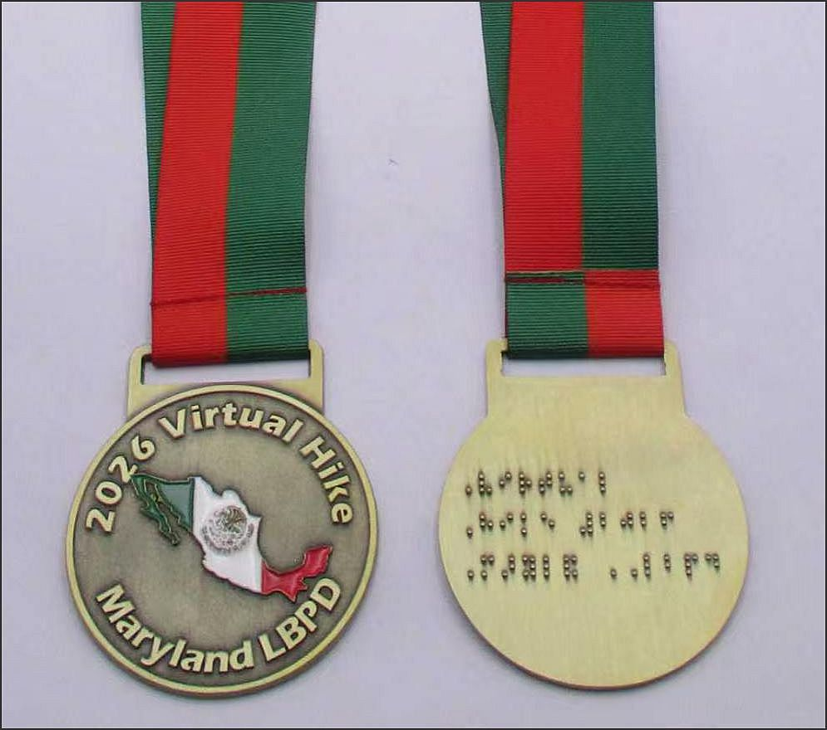
LBPD Outreach Librarian Ashley Biggs coordinated a popular Virtual Hike through Mexico in April. This program invited LBPD patrons to learn about Mexican history and culture by reading, listening to music, tasting food, and experiencing events. Launched nationwide this year for the first time, participants attended accessible events like author talks, music performances, cooking and others, earning miles by reading and engaging in physical activities. There were eighty registrants from nine states.

Ashley’s intention as Outreach Librarian was to expand existing connections between the Library and community partners. Patrons from LBPD had access to accessible PDF bingo sheets, Mexican crossword puzzles, digital quizzes, and a virtual cooking class, some of which LBPD Friends supported. Medals with Braille and tactile maps of Mexico also funded by the Friends were awarded to thirty-five
Marylanders who completed the hike. This virtual hike proved so popular and successful that it will be staged again in 2027 with a completely new theme!

Hiker Elizabeth Roth said, “Thank you, Ashley, and everyone concerned for the decision to include other Blind and Print Disabled Libraries in on the hike. It was a wonderful, engaging, fun, enriching, creative and highly accessible community on-line event. It was wonderful to feel part of something so big and well put together for us.

Mark your calendars!

On Sunday September 27 at 4 p.m. Robyn Hughes and Janet Sanford will host the Friends of LBPD annual Hikeathon fundraiser at the Hilton Area of the Patapsco State Park in Catonsville! This is always a fun event in a peaceful leafy park with a Braille Trail filled with informational signs, outdoor musical instruments, birdhouses, and scented herb-raised beds for investigation. The roped-hike is accessible to all, and less than a quarter-mile loop. We usually go around it a few times and then convene at picnic tables nearby for a shared dinner. It’s a great way to get to know folks from the LBPD community and to contribute to the Friends of LBPD.
Upon arrival, the Ranger will direct you to the Hilton area. There is a $3.00 fee. If the light and the weather hold out, there are other trails and hikes throughout the park. Hope to see you there!

You won’t believe the celebrity who is coming to speak
at our next annual meeting!


Our special guest will be Dan Rodricks, local Baltimore columnist formerly with the Baltimore Sun and now writing for the Baltimore Brew and Fishbowl. He is also a playwright, and radio commentator for WYPR, and the author of three books.

Saturday, October 24, 2025, at 9:30 a.m.
415 Park Ave., Baltimore, MD 21090

Image-Dan Rodricks

Friends of MDLBPH
672 Old Mill Road, 128
Millersville, MD 21108

